Supplememntary Figures

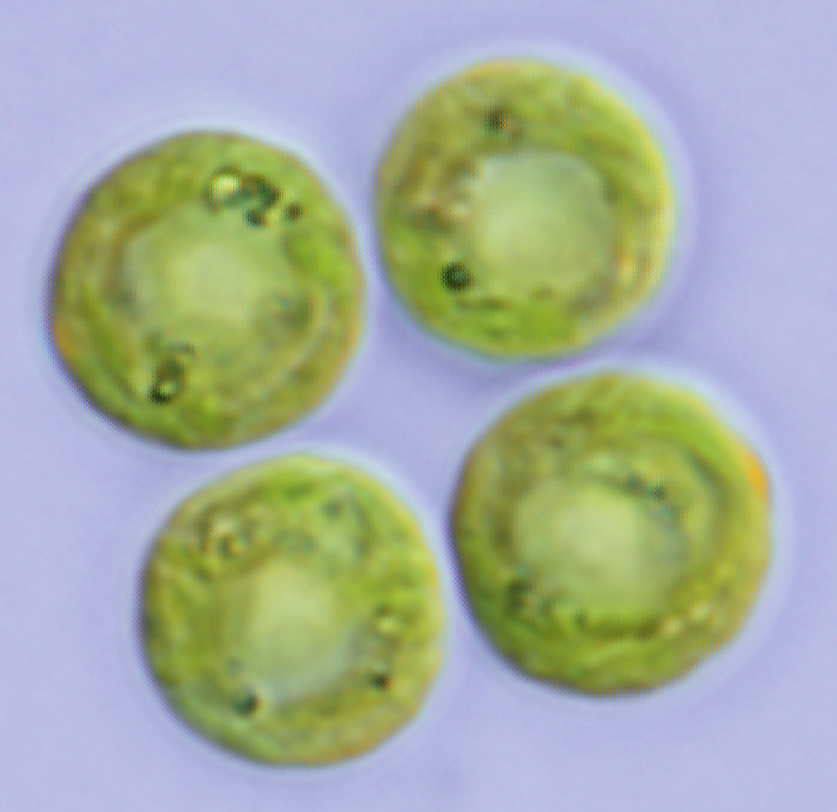

Supplementary Figure 1: A light microscope image of *Tetrabaena socialis*.

The extracellular matrix surrounding each cell is faintly visible.

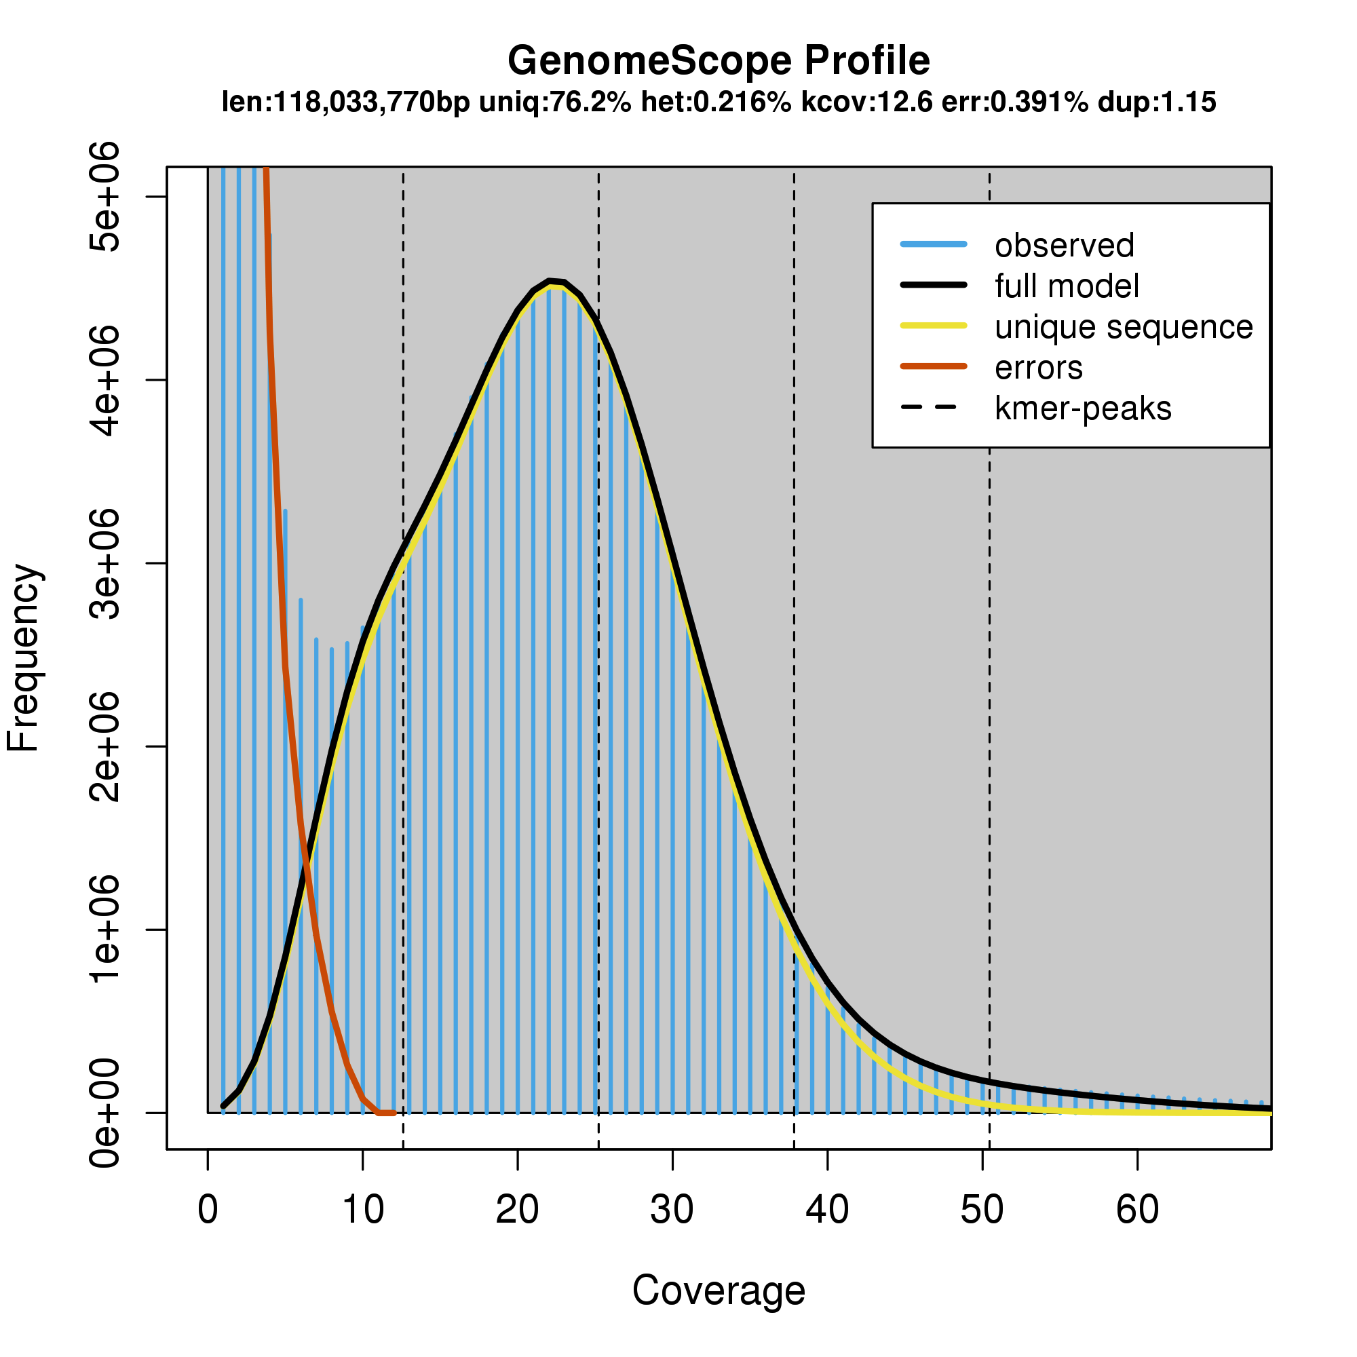

Supplementary Figure 2: Kmer frequency plot.

Kmer counting was performed using Jellyfish and the outputs were used to estimate genome size using GenomeScope. Presented here is a k of 77.



Supplementary Figure 3: Venn diagram of orthologous genes amongst volvocine algae. The abbreviations Crei, Tsoc, Gpec and Vcar denote *Chlamydomonas reinhardtii, Tetrabaena socialis, Gonium pectorale* and *Volvox carteri*. Image generated using OrthoVenn with OrthoMCL families as an input.

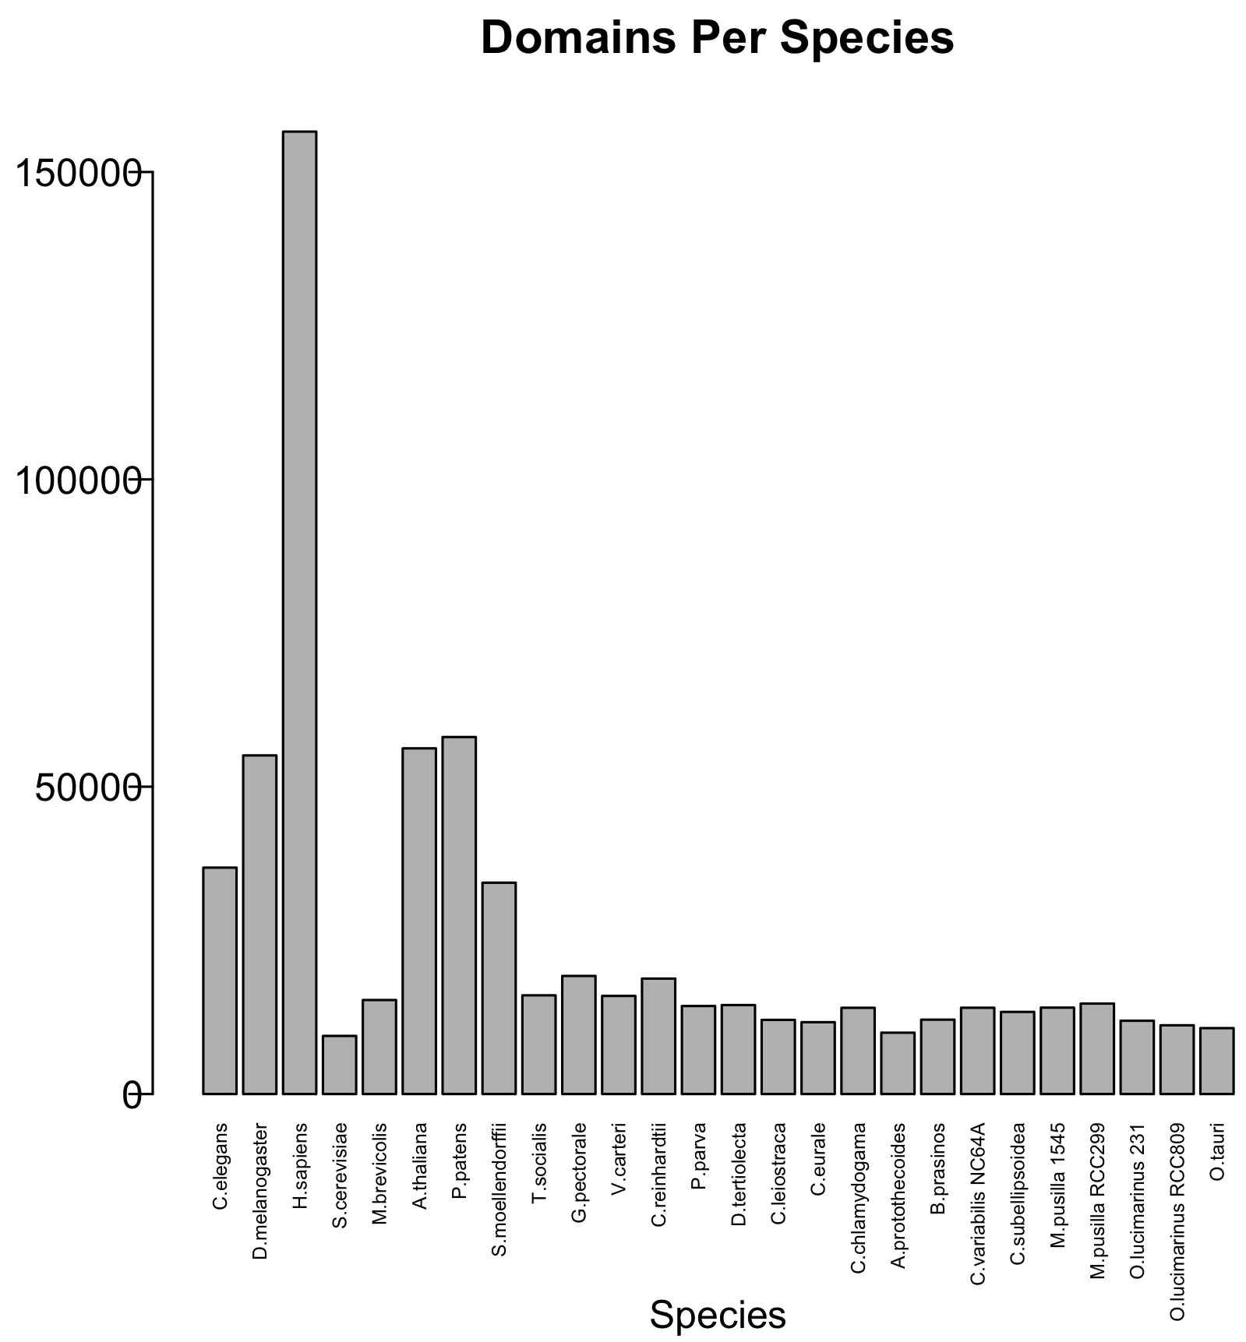

Supplementary Figure 4: The number of Pfam-A domains identified in the proteomes of each species examined using HMMER3.

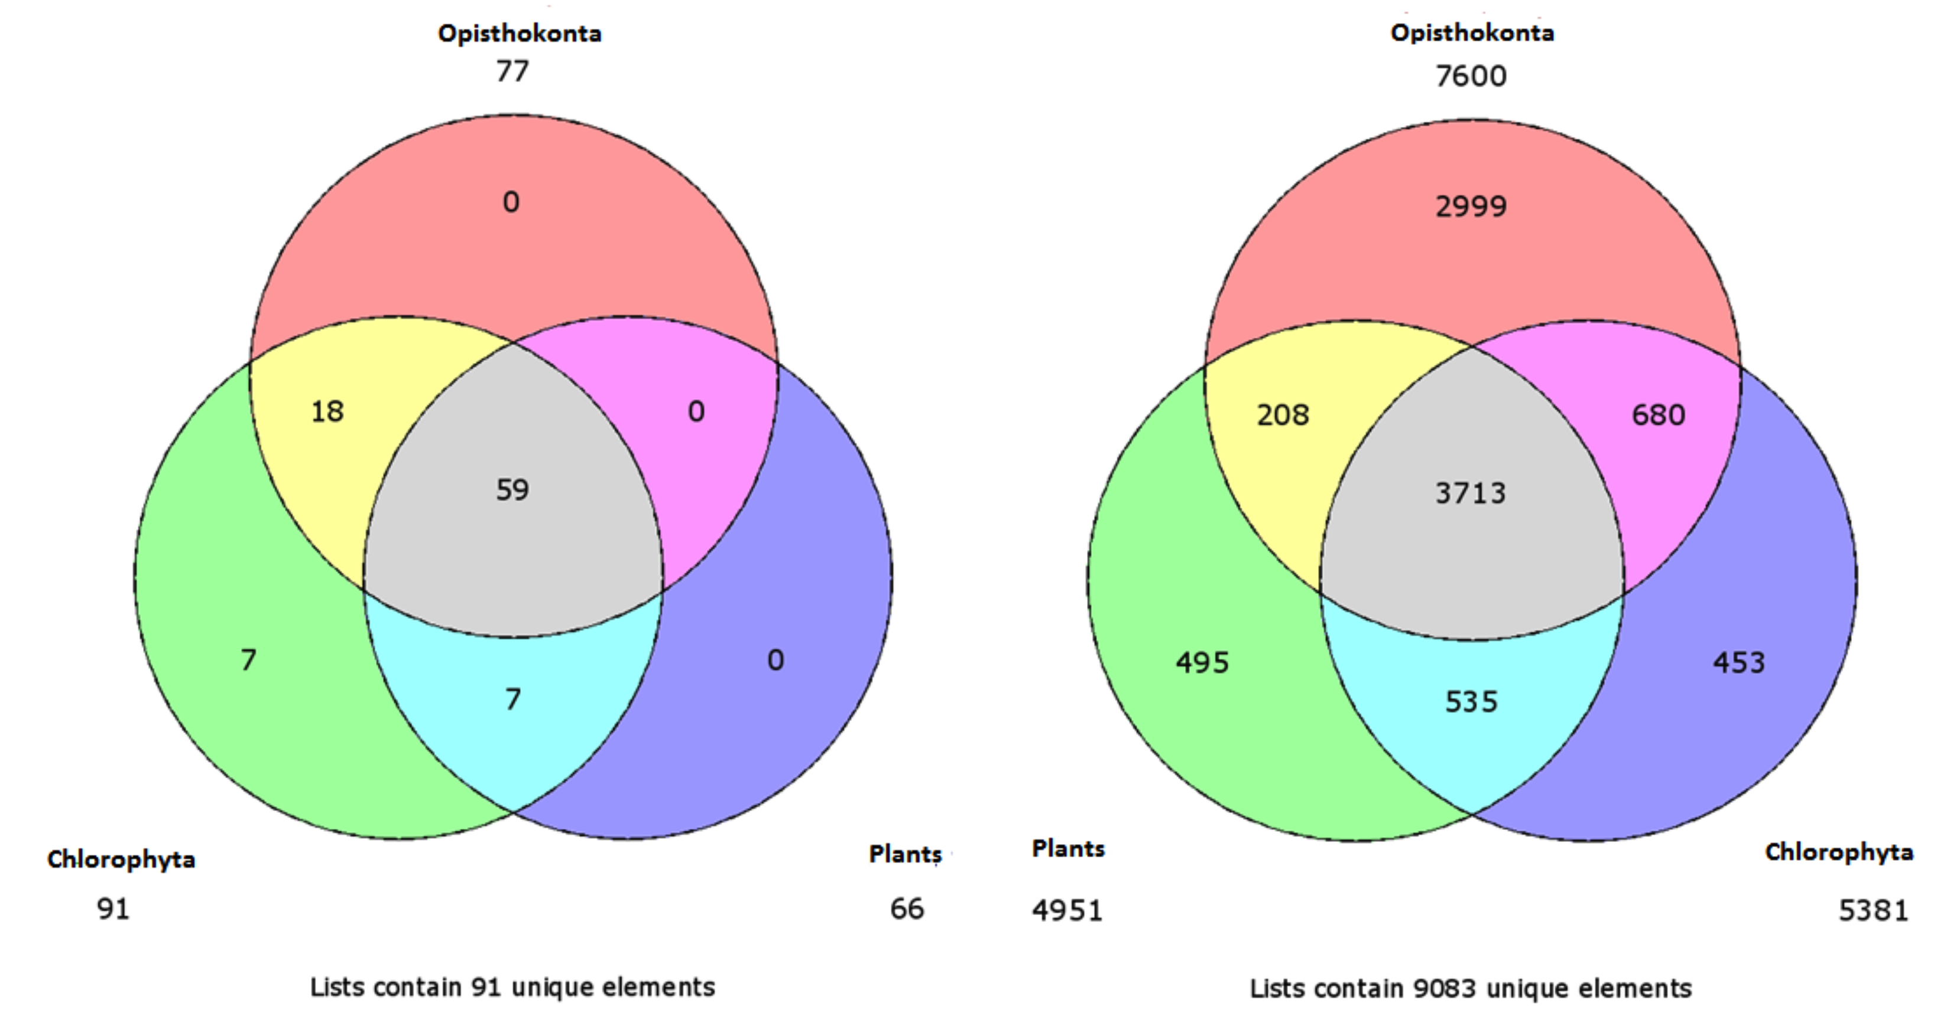

Supplementary Figure 5. Multicellular and enriched domains as categorised by presence in selected chlorophytes, plants and opisthokonta. In the left Venn diagram identified Pfam-A domains were sorted for presence amongst selected chlorophytes, plants and opisthokonta. In the right Venn diagram enriched domains between *Chlamydomonas reinhardtii* and the multicellular taxa as well as multicellular domains were sorted according to the distribution of domains amongst selected chlorophyta, plantae and opisthokonta as represented in the left Venn diagram.

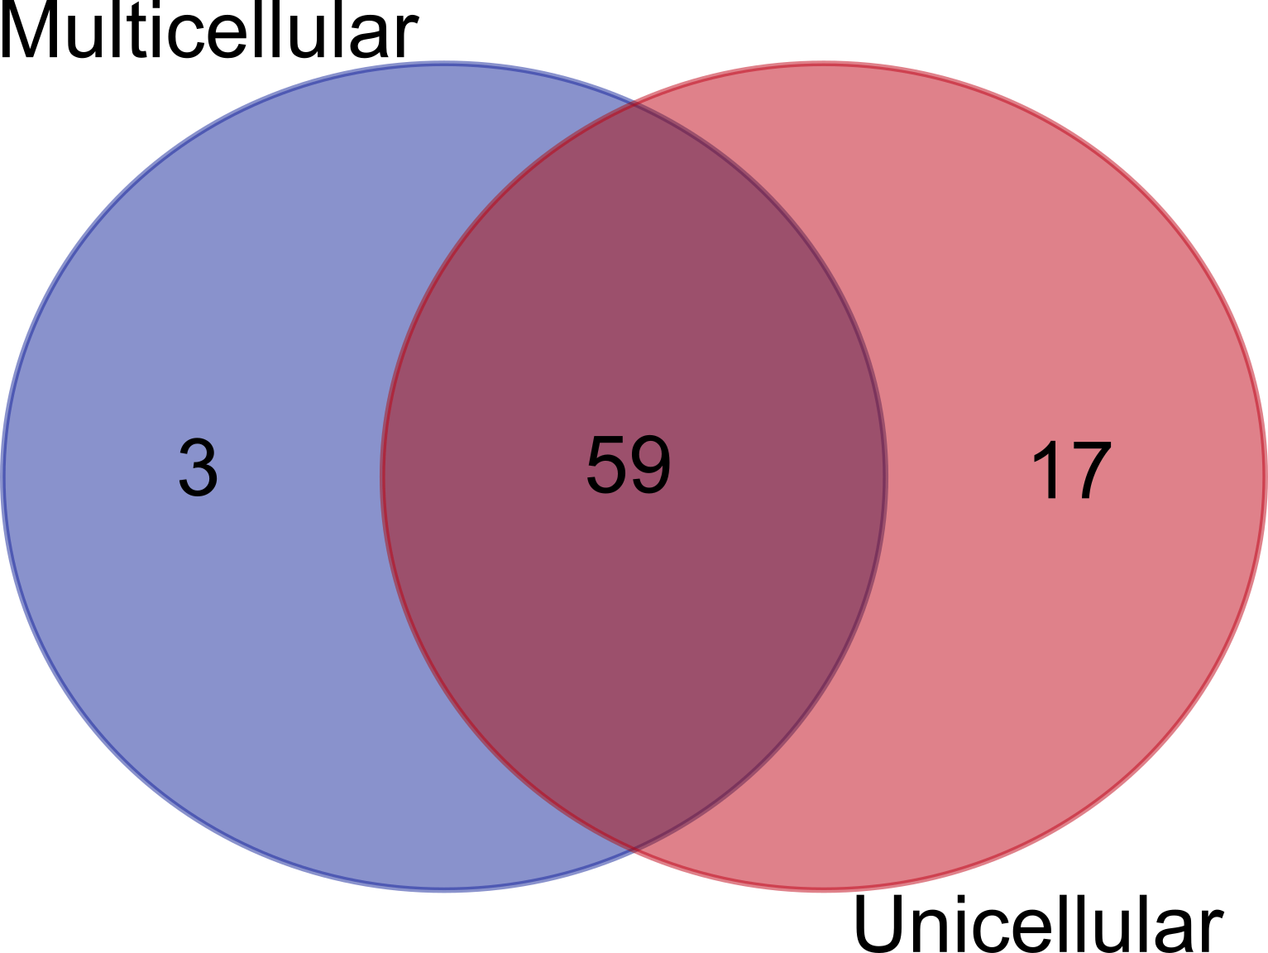

Supplementary Figure 6: Venn Diagram of BLASTP matches of origin of multicellularity family proteins to the RefSeq database.

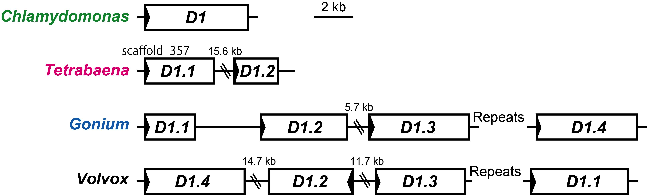

Supplementary Figure 7: Synteny relationships of *CYCD1* genes



Supplementary Figure 8: Mid-root phylogeny of cyclin-dependent kinases and rhodanese/cell-cycle phosphatases (RDPs). Cyclin-dependent kinases from *Chlamydomonas reinhardtii* (green), *Tetrabaena socialis* (magenta), *Gonium pectorale* (blue) and *Volvox carteri* (black).



Supplementary Figure 9: MAT3/RB alignment and putative cyclin-dependent kinase phosphorylation targets.

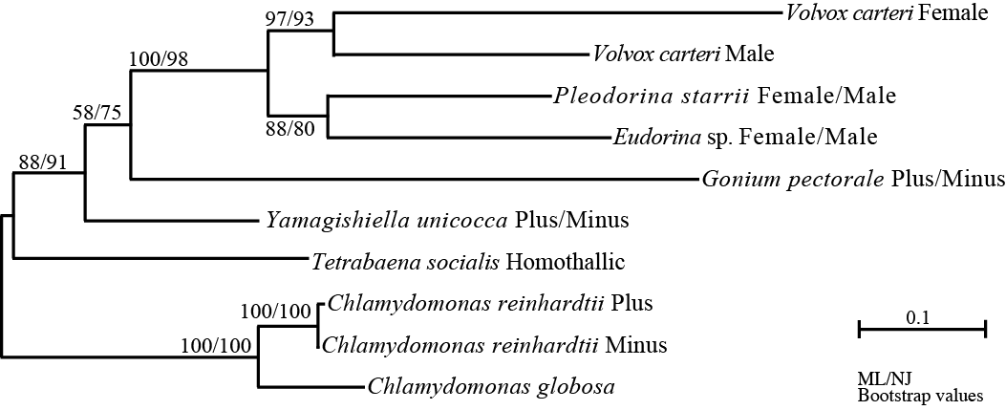

Supplementary Figure 10: Maximum-likelihood (ML) tree of RB/MAT3 of volvocine algae.

Bootstrap values (≥50%) for the ML and neighbor-joining (NJ) analyses are indicated left and right side, respectively. The scale bar corresponds to 0.1 amino acid substitutions per position.

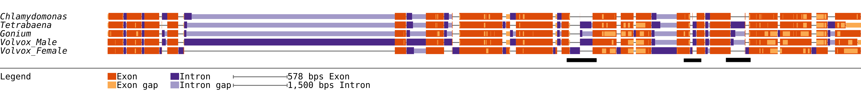

Supplementary Figure 11: Retinoblastoma gene structures of genome sequenced volvocines. Black bars underline regions where introns have been gained in the colonial/multicellular taxa.

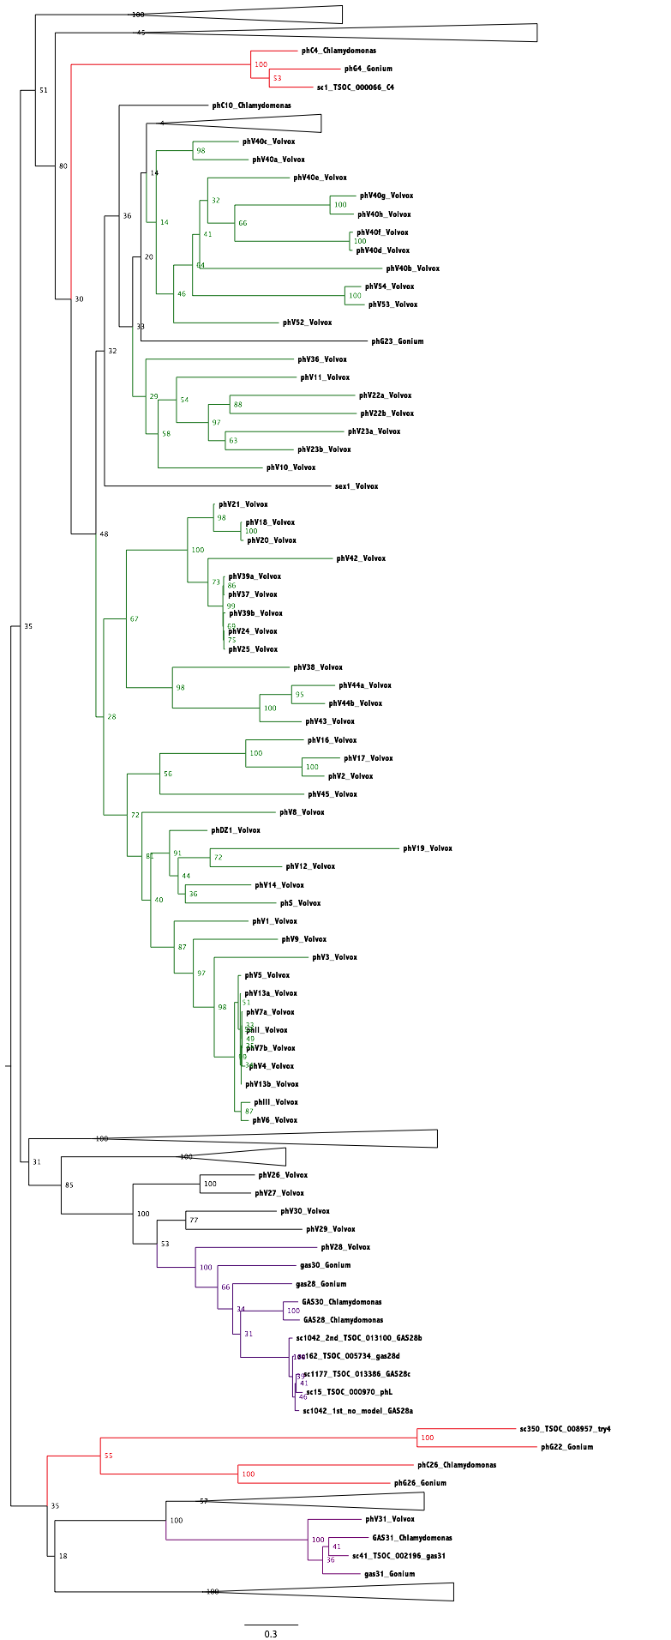

Supplementary Figure 12: Mid-pointed rooted phylogeny of pherophorins from *Chlamydomonas reinhardtii*, *Tetrabaena socialis*, *Gonium pectorale* and *Volvox carteri*.

Proteins were from Hanschen et al (2016) collection of curated pherophorins with the addition of *Tetrabaena socialis* proteins. Nodes where proteins from all taxa were present were collapsed in order to simplify the image. Highlighted in green are nodes and branches that consist exclusively of *Volvox carteri* proteins, in red are branches where *Volvox carteri* proteins are absent and in purple are branches that contain *Chlamydomonas reinhardtii* hydroxyproline-rich glycoproteins upregulated during N-starvation (GAS proteins) as well as homologues from *Gonium pectorale*, *Tetrabaena socialis* and *Volvox carteri*.

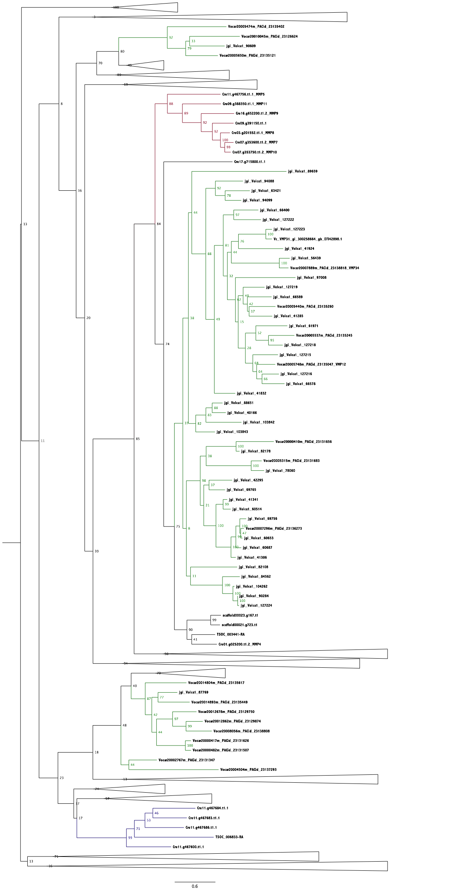

Supplementary Figure 13: Mid-pointed rooted phylogeny of Matrix Metalloproteases from *Chlamydomonas reinhardtii*, *Tetrabaena socialis*, *Gonium pectorale* and *Volvox carteri*.

Proteins were from Hanschen et al (2016) collection of curated MMPs with the addition of *Tetrabaena socialis* proteins. Nodes where proteins from three or more taxa were present were collapsed in order to simplify the image. Highlighted in green are nodes and branches that consist exclusively of *Volvox carteri* proteins, in red *Chlamydomonas reinhardtii* proteins and in blue a branch with only *Chlamydomonas reinhardtii* and *Tetrabaena socialis* proteins.

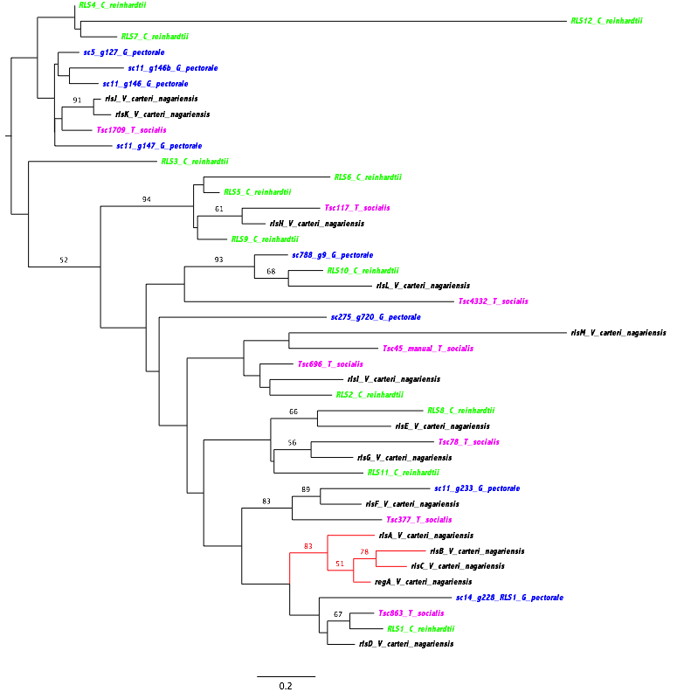

Supplementary Figure 14: Mid-root phylogeny of RegA-related sequences from *Chlamydomonas reinhardtii*, *Tetrabaena socialis*, *Gonium pectorale* and *Volvox carteri*.

RegA-related sequences from *Chlamydomonas reinhardtii* (green), *Tetrabaena socialis* (magenta), *Gonium pectorale* (blue) and *Volvox carteri* (black). The phylogeny was generated from an alignment of only the conserved VARL domain region. The phylogeny confirms that the regA-cluster of proteins (denoted by red branches that include regA, rlsA, rlsB and rlsC) is not present in *Tetrabaena socialis*. RLS1/rlsD proteins are shown as sister to the regA-cluster but without significant support.

Supplementary Table 1: Kmer analysis with Jellyfish, Allpaths-LG and BBtools. A substantial variance was observed between different tools or kmer sizes and a consensus for genome size or repeat content was not obtained.

|  |  |  |
| --- | --- | --- |
| Kmer/algorithm | Estimated Genome Size (mb) | Repeat content (%) |
| Jellyfish/GenomeScope |  |  |
| K=19 | 101,475 | 20,4% |
| K=21 | 102,175 | 17,9% |
| K=25 | 103,308 | 16,7% |
| K=33 | 105,230 | 16,1% |
| K=45 | 108,311 | 16,9% |
| K=55 | 111,586 | 18,9% |
| K=77 | 117,848 | 23,7% |
| Allpaths-LG |  |  |
| K=25 | 178,9 | 43% |
| BBtools |  |  |
| K=31 | 114,954 | 10,8% |

Supplementary Table 2: Sources of data used in comparative genome analyses.

|  |  |  |  |
| --- | --- | --- | --- |
| Organism | Version | Source | Reference |
| Chlamydomonas reinhardtii (Chlorophyte: Chlamydomonadales) | Version 5.5, Version 5.5 | http://phytozome.jgi.doe.gov/ | (Blaby et al., 2014; S. S. Merchant et al., 2007) |
| Volvox carteri (Chlorophyte: Chlamydomonadales) | Version 1, Version 2.0, Version 2.X | http://genome.jgi.doe.gov/ and http://phytozome.jgi.doe.gov/ | (Prochnik et al., 2010) |
| Gonium pectorale (Chlorophyte: Chlamydomonadales) | Version 1 | Volvocales Genome Consortium now available at  http://www.ncbi.nlm.nih.gov/genome/?term=gonium+pectorale | (Hanschen et al., 2016) |
| Ostreococcus tauri (Chlorophyte) | Version 2 | http://genome.jgi.doe.gov/ | (Hindle et al., 2014) |
| Ostreococcus RCC809 (Chlorophyte) | Version 2 | http://genome.jgi.doe.gov/ | (Palenik et al., 2007) |
| Ostreococcus lucimarinus (Chlorophyte) | Version 2 | http://genome.jgi.doe.gov/ | (Palenik et al., 2007) |
| Chlorella viriabilis (NC64)  (Chlorophyte) | Version 1 | http://genome.jgi.doe.gov/ | (Blanc et al., 2010) |
| Micromonas pusilla CCMP1545 (Chlorophyte) | Version 3 | http://genome.jgi.doe.gov/ | (Worden et al., 2009) |
| Micromonas pusilla RCC299 (Chlorophyte) | Version 3 | http://genome.jgi.doe.gov/ | (Worden et al., 2009) |
| Coccomyxa subellipsoidea (Chlorophyte) | Version 2 | http://genome.jgi.doe.gov/ | (Blanc et al., 2012) |
| Dunaliella tertiolecta  (Chlorophyte: Chlamydomonadales) | Version 1 (Transcriptome) | http://marinemicroeukaryotes.org/ | (Rismani-yazdi et al., 2011) |
| Polytomella parva (Chlorophyte: Chlamydomonadales) | Version 1 (Transcriptome) | http://marinemicroeukaryotes.org/ | (Smith & Lee, 2014) |
| Chlamydomonas leiostraca (Chlorophyte: Chlamydomonadales) | Version 1 (Transcriptome) | http://marinemicroeukaryotes.org/ | (Keeling et al., 2014) |
| Chlamydomonas chlamydogama  (Chlorophyte: Chlamydomonadales) | Version 1 (Transcriptome) | http://marinemicroeukaryotes.org/ | (Keeling et al., 2014) |
| Chlamydomonas eurale (Chlorophyte: Chlamydomonadales) | Version 1 (Transcriptome) | http://marinemicroeukaryotes.org/ | (Keeling et al., 2014) |
| Bathycoccus prasinos  (Chlorophyte: Chlamydomonadales) | Version 1 | http://bioinformatics.psb.ugent.be/ | X(Moreau et al., 2012) |
| Auxenochlorella protothecoides  (Chlorophyte) | Version 1 | www.ncbi.nlm.nih.gov/) | (C. Gao et al., n.d.) |
| Caenorhabditus elegans (Metazoan) | Version 84.245 | http://www.wormbase.org/ | (Equence & Iology, 2012) |
| Drosophila melanogaster (Metazoan) | Version 6 | http://www.flybase.net/ | (Ketchum et al., 2000) |
| Selaginella moellendorffii (Plant) | Version 1 | http://phytozome.jgi.doe.gov/ | (Banks et al., 2007) |
| Arabidopsis thaliana (Plant) | TAIR10 | https://www.arabidopsis.org/download/index-auto.jsp?dir=/download_files/Proteins |  |
| Physcomitrella patens (Plant) | Version 3.3 | http://phytozome.jgi.doe.gov/ | (Shapiro et al., 2008) |
| Monosiga brevicolis (Metazoan) | Version 1 | http://genome.jgi.doe.gov/ | (King et al., 2008) |
| Saccharomyces cerevisea (Fungi) | Version R64.2.1 | http://www.yeastgenome.org/ | (Mewes et al., 1997) |
| Homo sapiens (Metazoan) | Version 84.20 | http://www.ensembl.org/ | (Venter et al., 2001) |

Supplementary Table 3: BLAST results of *Tetrabaena socialis* proteins against UNIPROT and the proteomes of other volvocines. Note that results include only top blast hits (E-values <1x10-7).

|  |  |
| --- | --- |
| Query Proteomes | Tetrabaena socialis matches (15 153 proteins) |
| C. reinhardtii | 12 954 (83.5%) |
| G. pectorale | 12 740 (82.1%) |
| V. carteri | 12 218 (78.7%) |
| Volvocines | 13 712 (88.3) |
| UNIPROT-SWISSPROT | 7 838 (50.5) |
| UNIPROT-TREMBL | 13 091 (84.3%) |
| All Blast hits | 13 982 (90%) |

Supplementary Table 4: The number of *Chlamydomonas reinhardtii* orthologues for multicellular volvocines. Percentages reflect the percentage of the multicellular volvocine proteins with *Chlamydomonas reinhardtii* orthologues.

|  |  |  |
| --- | --- | --- |
|  | Chlamydomonas reinhardtii Orthologues | Proteins from multicelled taxa with Chlamydomonas reinhardtii orthologues. |
| Tetrabaena socialis | 8931 | 57,5% |
| Gonium pectorale | 9384 | 55,8% |
| Volvox carteri | 9384 | 64% |

Supplementary Table 5: Domains that are significantly different (p=0,05) between *Chlamydomonas reinhardtii* and the multicellular volvocines. Domains are classified for presence amongst major eukaryotic lineages examined. A (+) symbol in column 3 indicates that domains are enriched in multicellular volvocines. Domains with an (X) in column 2 indicate that they are absent from *Chlamydomonas reinhardtii* but present in the proteomes of all 3 multicellular volvocines (*Tetrabaena socialis*, *Gonium pectorale* and *Volvox carteri*). P-values in bold (n=12) are domains that are significantly different after false discovery rate correction (q=0.05).

|  |  |  |  |
| --- | --- | --- | --- |
| PFAM Domain | P-value | Enriched Multicell-ular (+/-) | Annotation of Domain |
| Common to all examined Eukaryotic lineages | | | |
| PF00331 | X |  | Glycosyl hydrolase family 10 |
| PF00832 | X |  | Ribosomal L39 protein |
| PF02320 | X |  | Ubiquinol-cytochrome C reductase hinge protein |
| PF03671 | X |  | Ubiquitin fold modifier 1 protein |
| PF05557 | X |  | Mitotic checkpoint protein |
| PF06331 | X |  | Transcription factor TFIIH complex subunit Tfb5 |
| PF06645 | X |  | Microsomal signal peptidase 12 kDa subunit (SPC12) |
| PF07145 | X |  | Ataxin-2 C-terminal region |
| PF07720 | X |  | Tetratricopeptide repeat |
| PF09202 | X |  | Rio2, N-terminal |
| PF10138 | X |  | vWA found in TerF C terminus |
| PF10537 | X |  | ATP-utilising chromatin assembly and remodelling N-terminal |
| PF11559 | X |  | Afadin- and alpha -actinin-Binding |
| PF12627 | X |  | Probable RNA and SrmB- binding site of polymerase A |
| PF13465 | X |  | Zinc-finger double domain |
| PF14811 | X |  | Protein of unknown function TPD sequence-motif |
| PF14822 | X |  | Vasohibin |
| PF13857 | **1,11E-16** | (+) | Ankyrin repeats (many copies) |
| PF13637 | **1,11E-16** | (+) | Ankyrin repeats (many copies) |
| PF00078 | **2,55E-15** | (-) | Reverse transcriptase (RNA-dependent DNA polymerase) |
| PF12796 | **1,40E-14** | (+) | Ankyrin repeats (3 copies) |
| PF13606 | **1,67E-10** | (+) | Ankyrin repeat |
| PF00023 | **9,29E-08** | (+) | Ankyrin repeat |
| PF01011 | **3,24E-05** | (-) | PQQ enzyme repeat |
| PF13360 | **1,44E-04** | (-) | PQQ-like domain |
| PF00652 | 3,63E-04 | (+) | Ricin-type beta-trefoil lectin domain |
| PF14291 | 4,11E-04 | (-) | Domain of unknown function (DUF4371) |
| PF01753 | 7,84E-04 | (+) | MYND finger |
| PF00010 | 9,45E-04 | (-) | Helix-loop-helix DNA-binding domain |
| PF00665 | 1,08E-03 | (+) | Integrase core domain |
| PF05686 | 1,16E-03 | (-) | Glycosyl transferase family 90 |
| PF14200 | 1,41E-03 | (+) | Ricin-type beta-trefoil lectin domain-like |
| PF07645 | 1,44E-03 | (-) | Calcium-binding EGF domain |
| PF01453 | 2,50E-03 | (+) | D-mannose binding lectin |
| PF00233 | 2,80E-03 | (-) | 3'5'-cyclic nucleotide phosphodiesterase |
| PF13570 | 3,71E-03 | (-) | PQQ-like domain |
| PF01663 | 4,69E-03 | (-) | Type I phosphodiesterase / nucleotide pyrophosphatase |
| PF07731 | 6,19E-03 | (-) | Multicopper oxidase |
| PF13371 | 8,49E-03 | (-) | Tetratricopeptide repeat |
| PF00059 | 1,26E-02 | (-) | Lectin C-type domain |
| PF08373 | 1,86E-02 | (-) | RAP domain |
| PF00394 | 1,94E-02 | (-) | Multicopper oxidase |
| PF13563 | 1,94E-02 | (-) | 2'-5' RNA ligase superfamily |
| PF00704 | 2,14E-02 | (-) | Glycosyl hydrolases family 18 |
| PF13738 | 2,51E-02 | (-) | Pyridine nucleotide-disulphide oxidoreductase |
| PF05729 | 2,53E-02 | (-) | NACHT domain |
| PF10275 | 2,53E-02 | (-) | Peptidase C65 Otubain |
| PF00884 | 2,60E-02 | (-) | Sulfatase |
| PF01541 | 2,63E-02 | (-) | GIY-YIG catalytic domain |
| PF07732 | 3,01E-02 | (-) | Multicopper oxidase |
| PF13405 | 3,03E-02 | (-) | EF-hand domain |
| PF00581 | 3,04E-02 | (-) | Rhodanese-like domain |
| PF13469 | 3,07E-02 | (-) | Sulfotransferase family |
| PF13499 | 3,35E-02 | (-) | EF-hand domain pair |
| PF13401 | 3,49E-02 | (-) | AAA domain |
| PF07676 | 3,55E-02 | (+) | WD40-like Beta Propeller Repeat |
| PF00188 | 4,20E-02 | (+) | Cysteine-rich secretory protein family |
| PF01636 | 4,56E-02 | (+) | Phosphotransferase enzyme family |
| PF13481 | 4,65E-02 | (-) | AAA domain |
|  |  |  |  |
| Unique to Chlorophytes and Opistokonta | | | |
| PF02607 | X |  | B12 binding domain |
| PF07221 | X |  | N-acylglucosamine 2-epimerase (GlcNAc 2-epimerase) |
| PF09594 | X |  | Protein of unknown function (DUF2029) |
| PF12051 | X |  | Protein of unknown function (DUF3533) |
| PF13358 | X |  | DDE superfamily endonuclease |
| PF13688 | X |  | Metallo-peptidase family M12 |
| PF14740 | X |  | Domain of unknown function (DUF4471) |
| PF14864 | X |  | Alkyl sulfatase C-terminal |
| PF05887 | **2,10E-06** | (-) | Procyclic acidic repetitive protein (PARP) |
| PF12851 | **1,19E-04** | (-) | Oxygenase domain of the 2OGFeDO superfamily |
| PF16588 | 6,17E-03 | (-) | C2H2 zinc-finger |
| PF07699 | 1,20E-02 | (-) | GCC2 and GCC3 |
| PF07562 | 1,49E-02 | (-) | Nine Cysteines Domain of family 3 GPCR |
| PF06701 | 1,73E-02 | (+) | Mib_herc2 |
| PF03762 | 2,83E-02 | (+) | Vitelline membrane outer layer protein I (VOMI) |
| PF02494 | 3,13E-02 | (+) | HYR domain |
| PF01822 | 3,47E-02 | (-) | WSC domain |
| PF01607 | 4,49E-02 | (-) | Chitin binding Peritrophin-A domain |
|  |  |  |  |
| Unique to Chlorophytes and Plants | | | |
| PF07123 | X |  | Photosystem II reaction centre W protein (PsbW) |
| PF08706 | X |  | D5 N terminal like |
| PF07460 | **2,44E-07** | (-) | NUMOD3 motif (2 copies) |
| PF00759 | 1,41E-03 | (+) | Glycosyl hydrolase family 9 |
| PF09118 | 1,09E-02 | (-) | Domain of unknown function (DUF1929) |
| PF07250 | 1,39E-02 | (-) | Glyoxal oxidase N-terminus |
| PF03924 | 2,32E-02 | (-) | CHASE domain |
|  |  |  |  |
| Unique to Chlorophytes | | | |
| PF02415 | X |  | Chlamydia PMP repeat |
| PF04230 | X |  | Polysaccharide pyruvyl transferase |
| PF08707 | X |  | Primase C terminal 2 (PriCT-2) |
| PF07282 | **1,55E-15** | (-) | Putative transposase DNA-binding domain |
| PF12499 | 1,89E-02 | (+) | Pherophorin |
| PF06863 | 1,44E-03 | (-) | Protein of unknown function (DUF1254) |
| PF06742 | 1,44E-03 | (-) | Protein of unknown function (DUF1214) |

Supplementary Table 6: Prochnik outlier domains identified in *Chlamydomonas reinhardtii*, *Tetrabaena socialis*, *Gonium pectorale* and *Volvox carteri*.

|  |  |  |  |  |  |
| --- | --- | --- | --- | --- | --- |
| Domain | Annotation | Chlamydomonas  reinhardtii | Tetrabaena socialis | Gonium pectorale | Volvox carteri |
| PF00125 | Histones | 124 | 170 | 134 | 56 |
| PF00023 | Ankyrin Repeats | 80 | 135 | 143 | 31 |
| PF00112 | Cysteine Protease | 24 | 17 | 18 | 16 |
| PF05548 | Gametolysin | 50 | 38 | 41 | 109 |
| PF00560 | Leucine-Rich Repeats | 36 | 39 | 21 | 23 |

Supplementary Table 7: HMMER3 detected Ankyrin repeat domains in *Chlamydomonas reinhardtii*, *Tetrabaena socialis*, *Gonium pectorale* and *Volvox carteri*.

|  |  |  |  |  |
| --- | --- | --- | --- | --- |
| Ankyrin Domains | Chlamydomonas reinhardtii | Tetrabaena socialis | Gonium pectorale | Volvox carteri |
| PF00023 | 104 | 203 | 253 | 61 |
| PF12796 | 208 | 416 | 518 | 111 |
| PF13606 | 112 | 247 | 286 | 70 |
| PF13637 | 158 | 383 | 476 | 99 |
| PF13857 | 150 | 365 | 403 | 105 |

Supplementary Table 8: Evaluation of parsimony implementations at 3 nodes in the phylogeny for family gain and loss

|  |  |  |  |
| --- | --- | --- | --- |
|  | Wagner’s symmetric (gain cost=1) | Wagner’s asymmetric (gain cost=2) | Dollo |
| Gonium/Volvox | 1248 gain  67 loss | 261 gain  317 loss | 234 gain  406 loss |
| Multicellular volvocines | 131 gain  137 loss | 517 gain  70 loss | 467 gain  111 gain |
| Chlorophyceae/  Trebouxiophyceae | 2657 gain  203 loss | 3099 gain  389 loss | 3455 gain  601 loss |

Supplementary Table 9: Gene Families gained at the ORIMC. The most common domain found is included as well as a description of the domain. Consensus annotations derived from *Chlamydomonas reinhardtii* v5.5 and Volvox carteri v2 annotations as well as from argot2 are provided for each family.

|  |  |  |  |
| --- | --- | --- | --- |
| Family ID | Common Domain/s | Domain/s Description | Description |
| OGFLEX_1019 | PF00069 | Protein kinase domain | STELAR K+ outward rectifier |
| OGFLEX_1034 | PF02389 | Cornifin (SPRR) family | Putative nucleic acid binding  family |
| OGFLEX_1035 | PF12796 | Ankyrin repeats (3 copies) | Ankyrin repeat family protein |
| OGFLEX_1046 | PF14295/  PF07645 | PAN domain/  Calcium-binding EGF domain | Cysteine proteinases  superfamily protein |
| OGFLEX_1063 | PF00008 | EGF-like domain | Cysteine proteinases  superfamily protein |
| OGFLEX_1079 |  |  | Unknown |
| OGFLEX_1126 | PF00211 | Adenylate and Guanylate cyclase  catalytic domain | Unknown putative signalling  functions |
| OGFLEX_1172 | PF00651 | BTB/POZ domain | BTB-POZ and MATH domain 6 |
| OGFLEX_1215 | PF03016 | Exostosin family | Exostosin family protein |
| OGFLEX_1256 |  |  | Unknown |
| OGFLEX_1271 | PF00098 | Zinc knuckle | General control non-repressible |
| OGFLEX_1382 | PF00188 | Cysteine-rich secretory protein family | Unknown |
| OGFLEX_1467 | PF07707 | BTB And C-terminal Kelch | Unknown |
| OGFLEX_1610 | PF14295 | PAN domain | Cysteine proteinases  superfamily |
| OGFLEX_1619 | PF02892 | BED zinc finger | Unknown |
| OGFLEX_2177 |  |  | Unknown |
| OGFLEX_4318 |  |  | Unknown |
| OGFLEX_4319 | PF05869 | DNA N-6-adenine-methyltransferase  (Dam) | Unknown putative  methyltransferase activity |
| OGFLEX_4334 | PF06645 | Microsomal signal peptidase  12 kDa subunit (SPC12) | Putative proteolytic signal  peptidase |
| OGFLEX_5276 |  |  | Unknown |
| OGFLEX_5317 | PF00188 | Cysteine-rich secretory protein family | CAP (Cysteine-rich secretory  proteins, Antigen 5, and  Pathogenesis-related 1 protein)  superfamily |
| OGFLEX_5320 | PF01549 | ShK domain-like | Similar to bacterial putative  methyl transferase |
| OGFLEX_5717 | PF00149 | Calcineurin-like phosphoesterase | Unknown hydrolase putative  activity |
| OGFLEX_5804 |  |  | Unknown glycine-rich family |
| OGFLEX_6272 | PF07714 | Protein tyrosine kinase | ACT-like protein tyrosine  kinase family protein |
| OGFLEX_7103 |  |  | Unknown |
| OGFLEX_7221 |  |  | Unknown |
| OGFLEX_7232 |  |  | Unknown |
| OGFLEX_7343 | PF03671 | Ubiquitin fold modifier 1 protein | Putative ubiquitin fold  modifier 1 protein |
| OGFLEX_7355 | PF00270 | DEAD/DEAH box RNA helicase family protein | RECQ helicase SIM |
| OGFLEX_7359 | PF13639 | Ring finger domain | RPM1 interacting protein 2 |
| OGFLEX_7429 | PF01762 | Galactosyltransferase | Galactosyltransferase family  protein |
| OGFLEX_7511 | PF07035 | Colon cancer-associated protein Mic1-like | Unknown putative microtubule  kinesin |
| OGFLEX_7538 | PF02535 | ZIP Zinc transporter | Zinc/iron permease |
| OGFLEX_8628 | PF00484 | Carbonic anhydrase | Unknown |
| OGFLEX_8632 | PF00076 | RNA recognition motif.  (a.k.a. RRM, RBD, or RNP domain) | Unknown putative nucleotide  binding |
| OGFLEX_8798 | PF14159 | CAAD domains of  cyanobacterial aminoacyl-tRNA  synthetase | Unknown |
| OGFLEX_8819 | PF00331 | Glycosyl hydrolase family | Glycosyl hydrolase family |
| OGFLEX_8913 | PF00535 | Glycosyl transferase family | Glycosyl transferase family |
| OGFLEX_8916 |  |  | Unknown |
| OGFLEX_8987 | PF00504 | Chlorophyll A-B binding protein | Chlorophyll A-B binding family |
| OGFLEX_9949 |  |  | Protein phosphatase 2C family |
| OGFLEX_9953 | PF02181 | Formin Homology 2 Domain | Putative formin like family |
| OGFLEX_9954 |  |  | MAPKKK-related family |
| OGFLEX_9968 |  |  | Unknown |
| OGFLEX_9969 | PF11822 | Domain of unknown function (DUF3342) | Unknown |
| OGFLEX_10455 | PF02469 | Fasciclin domain | Fasciclin domain containing family |
| OGFLEX_10485 | PF03016 | Exostosin family | Exostosin family protein |
| OGFLEX_10494 |  |  | Unknown |
| OGFLEX_10512 | PF14494 | Domain of unknown function (DUF4436) | Unknown |
| OGFLEX_10556 | PF05903 | PPPDE putative peptidase domain | Unknown |
| OGFLEX_10589 |  |  | Unknown |
| OGFLEX_10729 | SM00184 | Ring finger | Breast cancer susceptibility1 |
| OGFLEX_12088 | PF01145 | SPFH domain / Band 7 family | SPFH/Band 7/PHB domain-containing membrane-associated protein family |
| OGFLEX_12096 |  |  | Unknown |
| OGFLEX_12100 |  |  | Recovery protein 3 family |
| OGFLEX_12102 |  |  | Unknown |
| OGFLEX_12103 | PF00027 | Cyclic nucleotide-binding domain | Unknown |
| OGFLEX_12106 | PF08676 | MutL C terminal dimerisation domain | DNA mismatch repair protein, putative |
| OGFLEX_12109 |  |  | Unknown |
| OGFLEX_12898 | PF01189 | NOL1/NOP2/sun family | NOL1/NOP2/sun family protein |
| OGFLEX_13054 | PF04857 | CAF1 family ribonuclease | Polynucleotidyl transferase, ribonuclease H-like superfamily protein |
| OGFLEX_13080 | PF00069 | Protein kinase domain | Unknown putative protein kinase family |
| OGFLEX_13153 | PF10184 | Uncharacterized conserved protein (DUF2358) | Unknown |
| OGFLEX_13170 |  |  | Ribonuclease III family protein |
| OGFLEX_13210 | PF00160 | Cyclophilin type peptidyl-prolyl  cis-trans isomerase/CLD | Peptidyl-prolyl cis-trans isomerases |
| OGFLEX_13554 |  |  | Unknown |
| OGFLEX_13619 | PF07059 | Protein of unknown function (DUF1336) | Unknown |
| OGFLEX_13648 | SM00044 | Adenylyl- / guanylyl cyclase, catalytic domain | Unknown putative signalling functions |
| OGFLEX_14038 | SM00368 | Leucine rich repeat,  ribonuclease inhibitor type | Unknown |
| OGFLEX_14319 | PF00258 | Flavodoxin | Putative P450 family |
| OGFLEX_14401 | SM00380 | DNA-binding domain  in plant proteins  such as APETALA2 and EREBPs | AINTEGUMENTA-like 5 |
| OGFLEX_14433 |  |  | Unknown |
| OGFLEX_14435 | PF12624 | N-terminal region of Chorein,  a TM vesicle-mediated sorter | Autophagy 2 |
| OGFLEX_14464 | PF13532 | 2OG-Fe(II) oxygenase superfamily | 2OG-Fe(II) oxygenase superfamily |
| OGFLEX_14477 | PF04117 | Mpv17 / PMP22 family | Peroxisomal membrane  22 kDa (Mpv17/PMP22)  family |
| OGFLEX_14502 | PF03265 | Deoxyribonuclease II | Unknown |
| OGFLEX_14506 | PF02747 | Proliferating cell nuclear antigen,  C-terminal domain | Unknown |
| OGFLEX_14507 | PF04720 | Protein of unknown function (DUF506) | Protein of unknown function  (DUF506) |
| OGFLEX_14508 | PF00023 | Ankyrin repeat | Unknown |
| OGFLEX_14509 |  |  | Unknown |
| OGFLEX_14510 | PF02181 | Formin Homology 2 Domain | Actin-binding FH2 protein |
| OGFLEX_14511 | PF00458 | WHEP-TRS domain | Unknown |
| OGFLEX_14513 |  |  | Unknown |
| OGFLEX_14514 |  |  | Unknown |
| OGFLEX_14515 |  |  | Unknown |
| OGFLEX_14516 | PF09405 | CASC3/Barentsz eIF4AIII binding | CASC3/Barentsz  eIF4AIII binding |
| OGFLEX_14517 | PF02463 | RecF/RecN/SMC N terminal domain | Structural maintenance of  chromosome 3 |
| OGFLEX_14518 | PF13229 | Right handed beta helix region | ATPase, AAA-type, CDC48 family |
| OGFLEX_14519 |  |  | Unknown |
| OGFLEX_14521 | PF00069 | Protein kinase domain | Unknown putative protein  kinase family |
| OGFLEX_14522 | PF12906 | RING-variant domain | Unknown |
| OGFLEX_14523 |  |  | Unknown |
| OGFLEX_14525 |  |  | Unknown |
| OGFLEX_14526 | PF10049 | Protein of unknown function (DUF2283) | Unknown |
| OGFLEX_14527 |  |  | Unknown |
| OGFLEX_14528 |  |  | Unknown |
| OGFLEX_14529 | PF13414 | TPR repeat | FKBP-type peptidyl-prolyl  cis-trans isomerase  family protein |
| OGFLEX_14530 |  |  | Unknown |
| OGFLEX_14532 |  |  | Homeodomain-like/winged-helix  DNA-binding family protein |
| OGFLEX_14533 |  |  | Unknown |
| OGFLEX_14534 |  |  | Unknown |
| OGFLEX_14535 |  |  | Unknown |
| OGFLEX_14536 |  |  | Unknown |
| OGFLEX_14537 | PF08373 | RAP domain | RAP family |
| OGFLEX_14538 | PF07221 | N-acylglucosamine 2-epimerase  (GlcNAc 2-epimerase) | Putative cellobiose  epimerase |
| OGFLEX_14539 |  |  | Unknown |
| OGFLEX_14541 |  |  | Unknown |
| OGFLEX_14542 |  |  | Unknown |
| OGFLEX_14545 |  |  | Unknown |
| OGFLEX_14546 |  |  | Unknown |
| OGFLEX_14547 |  |  | Unknown |
| OGFLEX_14548 | PF04050 | Up-frameshift suppressor | Unknown RNA binding  protein family |
| OGFLEX_14549 |  |  | Unknown |
| OGFLEX_14550 | PF03982 | Diacylglycerol acyltransferase | Diacylglycerol acyltransferase  family |
| OGFLEX_14551 | PF00400 | WD domain, G-beta repeat | WD40/YVTN  repeat-like-containing  domain family |
| OGFLEX_14552 |  |  | FMN binding family |
| OGFLEX_14553 | PF00069 | Protein kinase domain | PAS domain-containing  protein tyrosine kinase  family |
| OGFLEX_14554 | PF01814 | Hemerythrin HHE cation binding domain | Unknown |
| OGFLEX_14555 | PF12051 | Protein of unknown function (DUF3533) | Unknown |
| OGFLEX_14556 | PF08574 | Protein of unknown function (DUF1762) | Unknown |
| OGFLEX_14557 | PF03600 | Citrate transporter | Unknown |
| OGFLEX_14559 |  |  | Unknown |
| OGFLEX_14560 | PF09359 | VTC domain | Unknown |
| OGFLEX_14561 |  |  | Unknown |
| OGFLEX_14562 | PF01434 | Peptidase family M41 | FTSH protease 10 family |
| OGFLEX_14563 | PF01544 | CorA-like Mg2+ transporter protein | Magnesium transporter 9 |
| OGFLEX_14564 | PF00400 | WD domain, G-beta repeat | Transducin family protein  / WD-40 repeat family |
| OGFLEX_14566 | PF03016 | Exostosin family | Exostosin family protein |
| OGFLEX_14567 | PF01124 | MAPEG family | Unknown |
| OGFLEX_14568 |  |  | Unknown |

Supplementary Table 10: Gene families expanded in multicellular volvocines. For column 3 only the most common domain within a family is listed. Column 4 includes *Chlamydomonas reinhardtii* v5.5 annotations.

|  |  |  |  |
| --- | --- | --- | --- |
| Gene Family | PFAM domain | Description of Domain | *Chlamydomonas reinhardtii* derived annotation |
| OGFLEX_1000 | PF12796 | Ankyrin repeats (3 copies) | Unknown |
| OGFLEX_1010 | PF03372 | Endonuclease/Exonuclease/phosphatase family | Unknown |
| OGFLEX_1022 | PF00078 | Reverse transcriptase (RNA-dependent DNA polymerase) | Unknown |
| OGFLEX_1097 | PF02889 | Sec63 Brl domain | U5 small nuclear ribonucleoprotein helicase, putative |
| OGFLEX_1274 | PF09359 | VTC domain | Major Facilitator Superfamily with SPX (SYG1/Pho81/XPR1) |
| OGFLEX_1334 | PF03054 | tRNA methyl transferase | tRNA (5-methylaminomethyl-2-thiouridylate)-methyltransferases |
| OGFLEX_1436 | PF02676 | Methyltransferase TYW3 | Met-10+ like family protein / kelch repeat-containing protein |
| OGFLEX_1480 | PF00069 | Protein kinase domain | casein kinase 1-like protein 2 |
| OGFLEX_1509 | PF08029 | HisG, C-terminal domain | ATP phosphoribosyl transferase 2 |
| OGFLEX_1575 | PF00069 | Protein kinase domain | Protein kinase superfamily protein/mixed-lineage kinase and Raf protein kinase-like |
| OGFLEX_1581 | PF00580 | UvrD/REP helicase N-terminal domain | P-loop containing nucleoside triphosphate hydrolases superfamily protein |
| OGFLEX_1614 | PF00504 | Chlorophyll A-B binding protein | photosystem I light harvesting complex gene 3 |
| OGFLEX_1895 | PF02922 | Carbohydrate-binding module 48 (Isoamylase N-terminal domain) | limit dextrinase |
| OGFLEX_1966 | PF00462 | Glutaredoxin | Glutaredoxin family protein |
| OGFLEX_2166 | PF00112 | Papain family cysteine protease | Cysteine proteinases superfamily protein |
| OGFLEX_2171 | PF00106 | short chain dehydrogenase | NAD(P)-binding Rossmann-fold superfamily protein |
| OGFLEX_3446 |  |  | Unknown |
| OGFLEX_3451 | PF13589 | Histidine kinase-, DNA gyrase B-, and HSP90-like ATPase | MUTL protein homolog 3 |
| OGFLEX_4309 | PF00232 | Glycosyl hydrolase family 1 | beta glucosidase 29 |
| OGFLEX_4312 | PF03992 | Antibiotic biosynthesis monooxygenase | Unknown |
| OGFLEX_4363 | PF12499 | Pherophorin | Unknown |
| OGFLEX_4885 | PF01494 | FAD binding domain | zeaxanthin epoxidase (ZEP) |
| OGFLEX_4887 | PF01485 | IBR domain | RING/U-box superfamily protein |
| OGFLEX_4915 | PF06650 | Protein of unknown function (DUF1162 | Unknown |
| OGFLEX_5737 | PF03351 | DOMON domain | Auxin-responsive family protein |
| OGFLEX_6377 | PF12499 | Pherophorin | Pherophorin |
| OGFLEX_6403 |  |  | Unknown |

Supplementary Table 11: Genes identified using the Potion pipeline and Codeml M7/8 model with significant (q=0.05) evidence of positive selection. Descriptions are from *Chlamydomonas reinhardtii* v5.5 annotations. Blank cells indicate that the gene has not been characterised.

|  |  |
| --- | --- |
| Chlamydomonas Reference Gene | Description |
| Cre01.g004500 | isopropyl malate isomerase large subunit 1 |
| Cre01.g016050 | Pre-mRNA-processing-splicing factor |
| Cre01.g034400 | NagB/RpiA/CoA transferase-like superfamily protein |
| Cre01.g043350 | Pheophorbide a oxygenase family protein with Rieske [2Fe-2S] domain |
| Cre01.g055420 | Protein phosphatase 2A, regulatory subunit PR55 |
| Cre02.g080200 | Transketolase |
| Cre02.g091050 | Aldolase superfamily protein |
| Cre02.g098450 | eukaryotic translation initiation factor 2 gamma subunit |
| Cre02.g113400 | |
| Cre02.g118900 | Metal-dependent protein hydrolase |
| Cre02.g143200 | Alanyl-tRNA synthetase |
| Cre03.g168450 | TCP-1/cpn60 chaperonin family protein |
| Cre03.g178150 | calmodulin 6 |
| Cre03.g180750 | methionine synthase 3 |
| Cre03.g183200 | adenosine monophosphate kinase |
| Cre03.g185550 | sedoheptulose-bisphosphatase |
| Cre03.g193850 | Succinyl-CoA ligase, alpha subunit |
| Cre04.g214500 | isocitrate dehydrogenase |
| Cre04.g216600 | regulatory particle triple-A ATPase 6A |
| Cre04.g229300 | rubisco activase |
| Cre05.g233800 | glycyl-tRNA synthetase / glycine--tRNA ligase |
| Cre05.g234639 | TCP-1/cpn60 chaperonin family protein |
| Cre05.g234652 | plastid transcriptionally active 17 |
| Cre06.g267350 | |
| Cre06.g269950 | ATPase, AAA-type, CDC48 protein |
| Cre06.g278142 | Methylthiotransferase |
| Cre06.g281250 | Cyclopropane-fatty-acyl-phospholipid synthase |
| Cre06.g294950 | NAD(P)-binding Rossmann-fold superfamily protein |
| Cre06.g308350 | flower-specific, phytochrome-associated protein phosphatase 3 |
| Cre06.g308500 | carbamoyl phosphate synthetase A |
| Cre07.g325500 | magnesium-chelatase subunit chlH, chloroplast, putative / Mg-protoporphyrin IX chelatase, putative (CHLH) |
| Cre07.g329700 | regulatory particle AAA-ATPase 2A |
| Cre07.g340350 | |
| Cre08.g359350 | acetyl Co-enzyme a carboxylase biotin carboxylase subunit |
| Cre08.g375500 | glutamine-fructose-6-phosphate transaminase (isomerizing)s;sugar binding;transaminases |
| Cre08.g378850 | Phosphoribosyltransferase family protein |
| Cre09.g394436 | Inorganic H pyrophosphatase family protein |
| Cre09.g405850 | NADH dehydrogenase subunit 7 |
| Cre09.g410950 | nitrate reductase 2 |
| Cre09.g415550 | |
| Cre10.g430050 | ubiquitin-conjugating enzyme 22 |
| Cre10.g433000 | glycine-tRNA ligases |
| Cre10.g434750 | ketol-acid reductoisomerase |
| Cre10.g439150 | regulatory particle triple-A ATPase 5A |
| Cre10.g449250 | |
| Cre10.g461050 | vacuolar ATP synthase subunit A |
| Cre11.g476850 | |
| Cre11.g481450 | ATPase, F0 complex, subunit B/B\', bacterial/chloroplast |
| Cre12.g483950 | Lactate/malate dehydrogenase family protein |
| Cre12.g484000 | acetyl-CoA carboxylase carboxyl transferase subunit beta |
| Cre12.g490350 | 4-hydroxy-3-methylbut-2-enyl diphosphate synthase |
| Cre12.g494900 | protein phosphatase X 2 |
| Cre12.g508150 | chromatin-remodeling protein 11 |
| Cre12.g514200 | Glucose-methanol-choline (GMC) oxidoreductase family protein |
| Cre12.g560900 | FAD/NAD(P)-binding oxidoreductase family protein |
| Cre13.g564250 | eukaryotic translation initiation factor 3A |
| Cre13.g568650 | Ribosomal protein S3Ae |
| Cre13.g572700 | FIZZY-related 3 |
| Cre13.g573351 | Ribosomal protein S5 domain 2-like superfamily protein |
| Cre13.g582201 | nudix hydrolase homolog 24 |
| Cre13.g584400 | |
| Cre13.g587050 | eukaryotic release factor 1-3 |
| Cre13.g606050 | Tyrosyl-tRNA synthetase, class Ib, bacterial/mitochondrial |
| Cre14.g612700 | Galactose oxidase/kelch repeat superfamily protein |
| Cre14.g625400 | regulatory particle triple-A 1A |
| Cre16.g666150 | |
| Cre16.g672385 | histidinol phosphate aminotransferase 1 |
| Cre16.g676197 | 26S proteasome regulatory subunit S2 1B |
| Cre17.g697450 | RNA polymerase I-associated factor PAF67 |
| Cre17.g703900 | Transducin/WD40 repeat-like superfamily protein |
| Cre17.g734200 | Pyridoxal phosphate (PLP)-dependent transferases superfamily protein |
| Cre17.g734450 | Ribosomal protein L19 family protein |

Supplementary Table 12: Gene ontology (GO) enrichment analysis of gene identified by Potion as positively selected (p<0.05). Gene ontology terms were derived from *Chlamydomonas reinhardtii* v5.5 annotations.

|  |  |
| --- | --- |
| Enriched GO terms | P-value |
| glycine-tRNA ligase activity | 0,00089293 |
| response to bacterium | 0,0013308 |
| defense response to bacterium | 0,0029941 |
| embryo sac development | 0,0035238 |
| carboxylic acid metabolic process | 0,0035564 |
| organic acid metabolic process | 0,0035564 |
| oxoacid metabolic process | 0,0035564 |
| ligase activity | 0,0041871 |
| cellular ketone metabolic process | 0,0044649 |
| response to biotic stimulus | 0,0049168 |
| glycoside biosynthetic process | 0,0049527 |
| proteasomal protein catabolic process | 0,0049527 |
| gametophyte development | 0,0050684 |
| acetyl-CoA carboxylase activity | 0,0051529 |
| response to cadmium ion | 0,0078005 |
| multicellular organismal development | 0,010828 |
| ligase activity, forming carbon-carbon bonds | 0,012392 |
| CoA carboxylase activity | 0,012392 |
| response to other organism | 0,014293 |
| amino acid activation | 0,016176 |
| tRNA aminoacylation | 0,016176 |
| tRNA aminoacylation for protein translation | 0,016176 |
| porphyrin biosynthetic process | 0,016176 |
| tetrapyrrole biosynthetic process | 0,01774 |
| fatty acid omega-oxidation | 0,018821 |
| glycyl-tRNA aminoacylation | 0,018821 |
| sucrose biosynthetic process | 0,018821 |
| meristem growth | 0,018821 |
| isocitrate metabolic process | 0,018821 |
| cellular response to redox state | 0,018821 |
| cell-cell signaling | 0,018821 |
| response to redox state | 0,018821 |
| response to metal ion | 0,019039 |
| multi-organism process | 0,020574 |
| ligase activity, forming aminoacyl-tRNA and related compounds | 0,023233 |
| ligase activity, forming carbon-oxygen bonds | 0,023233 |
| aminoacyl-tRNA ligase activity | 0,023233 |
| glycoside metabolic process | 0,023685 |
| defense response | 0,024101 |
| 5-methyltetrahydropteroyltriglutamate-homocysteine S-methyltransferase activity | 0,030189 |
| chlorophyllide a oxygenase activity | 0,030189 |
| 6-phosphogluconolactonase activity | 0,030189 |
| sedoheptulose-bisphosphatase activity | 0,030189 |
| transketolase activity | 0,030189 |
| oxidoreductase activity, acting on single donors with incorporation of molecular oxygen, incorporation of one atom of oxygen (internal monooxygenases or internal mixed function oxidases) | 0,030189 |
| ADP binding | 0,030189 |
| sugar binding | 0,030189 |
| ribulose-1,5-bisphosphate carboxylase/oxygenase activator activity | 0,030189 |
| isocitrate dehydrogenase (NADP+) activity | 0,030189 |
| mandelonitrile lyase activity | 0,030189 |
| 5-methyltetrahydrofolate-dependent methyltransferase activity | 0,030189 |
| 5-methyltetrahydropteroyltri-L-glutamate-dependent methyltransferase activity | 0,030189 |
| enoyl-[acyl-carrier-protein] reductase (NADH) activity | 0,030189 |
| enoyl-[acyl-carrier-protein] reductase activity | 0,030189 |
| nitrate reductase activity | 0,030189 |
| ketol-acid reductoisomerase activity | 0,030189 |
| carbamoyl-phosphate synthase (glutamine-hydrolyzing) activity | 0,030189 |
| methionine synthase activity | 0,030189 |
| porphobilinogen synthase activity | 0,030189 |
| glutamine-fructose-6-phosphate transaminase (isomerizing) activity | 0,030189 |
| intramolecular transferase activity, transferring hydroxy groups | 0,030189 |
| fatty acid metabolic process | 0,030597 |
| modification-dependent macromolecule catabolic process | 0,032164 |
| modification-dependent protein catabolic process | 0,032164 |
| ubiquitin-dependent protein catabolic process | 0,032164 |
| monocarboxylic acid metabolic process | 0,032197 |
| proteolysis involved in cellular protein catabolic process | 0,033778 |
| proteasome regulatory particle, base subcomplex | 0,034436 |
| porphyrin metabolic process | 0,035517 |
| alanyl-tRNA aminoacylation | 0,037295 |
| root cap development | 0,037295 |
| proteasome core complex assembly | 0,037295 |
| root morphogenesis | 0,037295 |
| maintenance of root meristem identity | 0,037295 |
| nitric oxide biosynthetic process | 0,037295 |
| nitric oxide metabolic process | 0,037295 |
| fatty acid biosynthetic process | 0,037902 |
| tetrapyrrole metabolic process | 0,037902 |
| response to inorganic substance | 0,039546 |
| carbohydrate biosynthetic process | 0,040367 |
| cellular nitrogen compound biosynthetic process | 0,041151 |
| chlorophyll biosynthetic process | 0,04378 |

Supplementary Table 13: Highly conserved elements identified by PhastCONS sorted by annotation feature. The features were derived from *Chlamydomonas reinhardtii* v5.5 annotations.

|  |  |
| --- | --- |
| Annotation Feature | Percentage of Conserved Bases (811 033bp) |
| Gene | 99,27% |
| Intergenic | 0,73% |
| 3 prime | 0,28% |
| 5 prime | 0,22% |
| Exon | 70,89% |
| CDS | 70,52% |
| Intron | 28,37% |

*Note: In alternative transcripts 3’ and 5’ regions may overlap with CDS regions from another alternative transcript and thus a degree of redundancy is included within these calculations. Highly conserved elements from transcribed but un-translated regions are estimated to amount to 0,37%.

Supplementary Table 14: Intergenic regions and nearby gene identified as highly conserved in the volvocine lineage. Conserved regions are referenced to the *Chlamydomonas reinhardtii* genome. In column 4 the distance of the conserved region to a coding locus is indicated (in base-pairs) such that a (-) symbol indicates that the locus is upstream of the coding locus and no symbol indicates that the region is downstream of the coding locus.

|  |  |  |  |  |
| --- | --- | --- | --- | --- |
| Chromosome | Conserved Region | Nearest Gene | Distance from Gene (bp) | Description |
| Chr1 | 1148-1170 | Cre01.g000017 | -17596 |  |
| Chr1 | 1958-1989 | Cre01.g000017 | -16777 |  |
| Chr1 | 2004-2150 | Cre01.g000017 | -16616 |  |
| Chr1 | 2164-2189 | Cre01.g000017 | -16577 |  |
| Chr1 | 2395-2441 | Cre01.g000017 | -16325 |  |
| Chr1 | 2648-2902 | Cre01.g000017 | -15864 |  |
| Chr1 | 2933-3146 | Cre01.g000017 | -15620 |  |
| Chr1 | 3250-3299 | Cre01.g000017 | -15467 |  |
| Chr1 | 16629-16726 | Cre01.g000017 | -2040 |  |
| Chr1 | 17000-17066 | Cre01.g000017 | -1700 |  |
| Chr1 | 17222-17281 | Cre01.g000017 | -1485 |  |
| Chr1 | 17301-17348 | Cre01.g000017 | -1418 |  |
| Chr1 | 17425-17497 | Cre01.g000017 | -1269 |  |
| Chr1 | 17512-17682 | Cre01.g000017 | -1084 |  |
| Chr1 | 17699-17762 | Cre01.g000017 | -1004 |  |
| Chr1 | 17885-18087 | Cre01.g000017 | -679 |  |
| Chr1 | 18348-18381 | Cre01.g000017 | -385 |  |
| Chr1 | 18427-18494 | Cre01.g000017 | -272 |  |
| Chr1 | 18534-18639 | Cre01.g000017 | -127 |  |
| Chr1 | 3126208-3126237 | Cre01.g019450 | 298 | sumo conjugation enzyme 1 |
| Chr1 | 3126243-3126274 | Cre01.g019450 | 333 |  |
| Chr1 | 3266665-3266702 | Cre01.g020650 | 1498 |  |
| Chr1 | 4858662-4858762 | Cre01.g033700 | -6758 | maternal effect embryo arrest 18 |
| Chr1 | 6221036-6221054 | Cre01.g044450 | 3082 |  |
| Chr1 | 6711070-6711145 | Cre01.g048200 | 904 | RNA helicase, putative |
| Chr10 | 1629927-1629966 | Cre10.g429750 | -2906 |  |
| Chr10 | 1629995-1630032 | Cre10.g429750 | -2840 |  |
| Chr10 | 1630207-1630227 | Cre10.g429750 | -2645 |  |
| Chr10 | 1631353-1631372 | Cre10.g429750 | -1500 |  |
| Chr11 | 479595-479627 | Cre11.g467595 | 1159 | Calcium-dependent lipid-binding (CaLB domain) family protein |
| Chr11 | 1888175-1888203 | Cre11.g468100 | 345 |  |
| Chr11 | 3521801-3521854 | Cre11.g481375 | -952 |  |
| Chr12 | 365823-365849 | Cre12.g494252 | -155 |  |
| Chr12 | 5562351-5562410 | Cre12.g531550 | -1269 | eukaryotic translation initiation factor 2 beta subunit |
| Chr12 | 5562763-5562788 | Cre12.g531550 | -891 |  |
| Chr12 | 6219399-6219432 | Cre12.g536683 | 211 |  |
| Chr12 | 6219506-6219562 | Cre12.g536683 | 81 |  |
| Chr12 | 9716381-9716416 | Cre12.g557503 | 1832 |  |
| Chr13 | 2602283-2602367 | Cre13.g581200 | 2164 |  |
| Chr13 | 3005242-3005263 | Cre13.g584250 | -1120 |  |
| Chr13 | 3005398-3005435 | Cre13.g584250 | -1276 |  |
| Chr13 | 3005560-3005628 | Cre13.g584250 | -1438 |  |
| Chr13 | 3005740-3005766 | Cre13.g584250 | -1618 |  |
| Chr13 | 3005806-3005867 | Cre13.g584250 | -1684 |  |
| Chr13 | 3005944-3005972 | Cre13.g584250 | -1822 |  |
| Chr14 | 1881883-1881971 | Cre14.g620702 | -4860 |  |
| Chr14 | 1882292-1882320 | Cre14.g620702 | -5269 |  |
| Chr14 | 1882933-1882952 | Cre14.g620702 | -5910 |  |
| Chr14 | 1883022-1883045 | Cre14.g620702 | -5999 |  |
| Chr14 | 4124838-4124905 | Cre14.g634193 | -611 |  |
| Chr15 | 1754425-1754438 | Cre15.g643515 | 1361 |  |
| Chr16 | 1072640-1072668 | Cre16.g649500 | -1196 |  |
| Chr16 | 1074963-1075035 | Cre16.g649550 | 935 |  |
| Chr16 | 2491796-2491852 | Cre16.g660850 | -449 |  |
| Chr16 | 2492003-2492046 | Cre16.g660850 | -656 |  |
| Chr16 | 6228369-6228387 | Cre16.g675050 | -375 |  |
| Chr16 | 6228409-6228427 | Cre16.g675050 | -415 |  |
| Chr16 | 6228581-6228605 | Cre16.g675050 | -587 |  |
| Chr17 | 4547861-4547933 | Cre17.g732700 | 2751 |  |
| Chr17 | 4885028-4885089 | Cre17.g734300 | -257 | translocon outer complex protein 120 |
| Chr2 | 6161018-6161173 | Cre02.g113600 | -1144 | ataurora3 |
| Chr2 | 6161454-6161502 | Cre02.g113600 | -1580 |  |
| Chr2 | 6162350-6162368 | Cre02.g113626 | 1752 |  |
| Chr2 | 9199259-9199274 | Cre02.g143647 | 255 |  |
| Chr4 | 1819109-1819129 | Cre04.g211850 | 1087 | Chlorophyll A-B binding family protein |
| Chr4 | 1880001-1880082 | Cre04.g211850 | 1252 |  |
| Chr4 | 1881351-1881432 | Cre04.g217900 | -1471 |  |
| Chr4 | 2179600-2179636 | Cre04.g219800 | 1117 |  |
| Chr4 | 2180593-2180643 | Cre04.g219851 | 1591 |  |
| Chr4 | 2270007-2270043 | Cre04.g220200 | -941 | K+ efflux antiporter 2 |
| Chr4 | 2824610-2824693 | Cre04.g224150 | 1114 | Actin-like ATPase superfamily protein |
| Chr5 | 685313-685348 | Cre05.g230800 | 1440 | SNF2 domain-containing protein / helicase domain-containing protein / F-box family protein |
| Chr5 | 714533-714606 | Cre05.g230600 | 264 | Regulator of chromosome condensation (RCC1) family protein |
| Chr5 | 715213-715284 | Cre05.g230600 | 944 |  |
| Chr5 | 3482251-3482286 | Cre05.g243358 | 848 |  |
| Chr5 | 3482295-3482346 | Cre05.g243358 | 788 |  |
| Chr6 | 3272450-3272470 | Cre06.g276950 | 19 | histone H2A 10 |
| Chr6 | 6607837-6607911 | Cre06.g276950 | 243 |  |
| Chr7 | 2239598-2239705 | Cre07.g327317 | 186 |  |
| Chr7 | 5851183-5851255 | Cre07.g353600 | 285 |  |
| Chr7 | 6205920-6205979 | Cre07.g356450 | 508 |  |
| Chr8 | 533541-533581 | Cre08.g359166 | -30 |  |
| Chr8 | 3473462-3473558 | Cre08.g374950 | -3949 |  |
| Chr8 | 3761889-3761931 | Cre08.g377200 | 606 | chromatin remodeling factor CHD3 (PICKLE) |
| Chr8 | 4810011-4810056 | Cre08.g384355 | 622 | P-loop containing nucleoside triphosphate hydrolases superfamily protein |
| Chr8 | 4810082-4810101 | Cre08.g384355 | 577 |  |
| Chr8 | 5030323-5030388 | Cre08.g386100 | -6689 |  |
| Chr8 | 5030444-5030656 | Cre08.g386100 | -6810 |  |
| Chr8 | 5030729-5030752 | Cre08.g386100 | -7095 |  |
| Chr8 | 5030778-5030875 | Cre08.g386100 | -7144 |  |
| Chr8 | 5030934-5031004 | Cre08.g386100 | -7300 |  |
| Chr9 | 584478-584579 | Cre09.g403700 | 944 |  |
| Chr9 | 2191673-2191696 | Cre09.g393100 | 3 |  |
| Chr9 | 2344681-2344706 | Cre09.g392105 | 89 |  |
| Chr9 | 2573667-2573687 | Cre09.g390678 | 867 | Protein phosphatase 2C family protein |
| Chr9 | 3997546-3997661 | Cre09.g392840 | -2250 |  |
| Chr9 | 3997748-3997799 | Cre09.g392840 | -2112 |  |
| Chr9 | 6120006-6120075 | Cre09.g405150 | 535 | Pseudouridine synthase family protein |
| Chr9 | 6429892-6429918 | Cre09.g407100 | -1051 | Ribosomal protein S5 family protein |
| Chr9 | 6475030-6475058 | Cre09.g407300 | 2135 | alpha/beta-Hydrolases superfamily protein |
| Chr9 | 6817306-6817396 | Cre09.g409728 | -1469 |  |

Supplementary Table 15: Genes evolving more rapidly in the multicellular volvocines than in *Chlamydomonas reinhardtii* but not necessarily faster than the neutral rate. Genes are sorted by putative functions into related to signalling, ubiquitination (the ubiquitin proteasomal pathway), membrane trafficking, cell cycle regulators, chaperone activity, integral components of the cytoskeleton, microtubule interacting kinesins and genes coding for DNA interacting proteins

|  |  |
| --- | --- |
| Gene Name/symbol/Description | Chlamydomonas reinhardtii identifier |
| Signalling | |
| Calcium-Ion Dependant or related: | |
| Calmodulin 4 (CAM4) | Cre06.g292150 |
| Centrin 2 (CEN2) | Cre01.g055428 |
| Kinesin-like calmodulin-binding (zwickel) | Cre06.g278125 |
| Membrane Trafficking: | |
| RAB GTPase homolog B1C member of RAB gene family (RABB1C) | Cre09.g390763 |
| Endomembrane protein 70 protein family | Cre01.g024350 |
| Major facilitator superfamily protein | Cre16.g688850 |
| Alpha-adaptin (alpha-ADR) | Cre12.g488850 |
| Sorting nexin 2B (SNX2b) | Cre07.g326450 |
| Importin alpha isoform 1 (IMP) | Cre04.g215850 |
| Importin alpha isoform 9 (IMPA-9) | Cre03.g161100 |
| Transporter associated with antigen processing protein 1 (TAP1) | Cre02.g083354 |
| Exostosin family protein | Cre02.g116600 |
| Serine/Threonine Kinases: | |
| Leucine-rich repeat receptor-like protein kinase family protein (FLS2) | Cre06.g269200 |
| Protein kinase family proteins: | Cre06.g281100 |
| Protein kinase superfamily protein (OST1) | Cre13.g568050 |
| Protein kinase superfamily protein | Cre16.g673821 |
| PAS-domain containing protein tyrosine kinase family protein | Cre13.g563300 |
| Serine/threonine protein kinase Rio1 | Cre13.g580900 |
| Cytoskeleton/Microtubule/Microtubule motor activity | |
| Myosin 1 (MYO1) | Cre09.g416250 |
| Tubulin beta chain 2 (TUB2) | Cre12.g542250 |
| Tubulin beta chain 2 (TUB2) | Cre13.g549550 |
| Spc97 / Spc98 family of spindle pole body (SBP) | Cre12.g525500 |
| P-loop containing nucleoside triphosphate hydrolases superfamily protein | Cre10.g427700 |
| P-loop containing nucleoside triphosphate hydrolases superfamily protein | Cre13.g568450 |
| Cell Cycle | |
| Retinoblastoma-related 1 (RB/MAT3) | Cre06.g255450 |
| Regulator of chromosome condensation family with FYVE zinc finger domain (RCC1) | Cre16.g691050 |
| Cell differentiation Rcd1-like protein | Cre12.g540400 |
| Cyclin-dependent kinase B1 (CDKB1) | Cre08.g372550 |
| Ataurora1 (AUR1) | Cre17.g719450 |
| Transducin/WD40 repeat-like superfamily protein | Cre06.g255400 |
| Transducin/WD40 repeat-like superfamily protein (ubiquitin-related) | Cre12.g522450 |
| Transducin family protein / WD-40 repeat family protein (CUL4 RING ubiquitin ligase complex) | Cre17.g703900 |
| Ubiquitination | |
| Ubiquitin activating enzyme 2 (UBA2) | Cre09.g386400 |
| Ubiquitin-protein ligase 1 (UPL1) | Cre10.g433900 |
| Chaperonins | |
| Heat shock protein 70A (HSP70A) | Cre08.g372100 |
| Heat shock protein 70 family member (BIP2) | Cre02.g080700 |
| DNA/RNA interacting | |
| Topoisomerase II (TOPII) | Cre01.g009250 |
| DNA-directed RNA polymerase family protein (NRPB2) | Cre02.g075150 |
| RNA polymerase II large subunit (NRPB1) | Cre16.g680900 |
| MEI2-like protein 5 RNA binding protein (AML5) | Cre07.g338150 |
| DNA/RNA-binding protein Kin17 | Cre16.g654350 |
| Squamosa promoter binding protein-like 1 (SPL1) | Cre09.g390023 |
| LA RNA-binding protein | Cre10.g441200 |
| Nuclear RNA polymerase C2 (NRPC2) | Cre12.g542800 |
| Decapping 2 (DCP2) | Cre07.g344850 |
| Myb domain protein 3r-5 (MYB3R-5) | Cre01.g034350 |

Supplementary table 16: Significantly enriched annotations associated with accelerating genes. Included are gene ontology terms, MapMAn annotations and KEGG pathways.

|  |  |  |
| --- | --- | --- |
| Annotation | Category/Level | P-value |
| Gene Ontology terms |  |  |
| deoxyribonucleotide metabolic process | Biological process (BP) | 0.0035976 |
| response to high light intensity | BP | 0.014487 |
| nucleobase, nucleoside and nucleotide metabolic process | BP | 0.01457 |
| nucleoside phosphate metabolic process | BP | 0.020628 |
| nucleotide metabolic process | BP | 0.020628 |
| acetate metabolic process | BP | 0.025094 |
| cellular monovalent inorganic cation homeostasis | BP | 0.025094 |
| deoxyribonucleoside triphosphate biosynthetic process | BP | 0.025094 |
| deoxyribonucleoside triphosphate metabolic process | BP | 0.025094 |
| ER-associated protein catabolic process | BP | 0.025094 |
| generative cell differentiation | BP | 0.025094 |
| L-phenylalanine biosynthetic process | BP | 0.025094 |
| maltose biosynthetic process | BP | 0.025094 |
| photosynthetic electron transport in cytochrome b6/f | BP | 0.025094 |
| regulation of cellular pH | BP | 0.025094 |
| regulation of intracellular pH | BP | 0.025094 |
| response to hydroperoxide | BP | 0.025094 |
| response to lipid hydroperoxide | BP | 0.025094 |
| response to non-ionic osmotic stress | BP | 0.025094 |
| S-adenosylmethionine biosynthetic process | BP | 0.025094 |
| S-adenosylmethionine metabolic process | BP | 0.025094 |
| response to light intensity | BP | 0.034549 |
| response to temperature stimulus | BP | 0.041941 |
| regulation of cell cycle | BP | 0.048085 |
| aromatic amino acid family biosynthetic process, prephenate pathway | BP | 0.049569 |
| actin filament-based movement | BP | 0.049569 |
| cytoskeleton-dependent intracellular transport | BP | 0.049569 |
| deoxyribonucleoside diphosphate metabolic process | BP | 0.049569 |
| deoxyribonucleotide biosynthetic process | BP | 0.049569 |
| L-phenylalanine metabolic process | BP | 0.049569 |
| monovalent inorganic cation homeostasis | BP | 0.049569 |
| nucleoside diphosphate metabolic process | BP | 0.049569 |
| nucleotide transport | BP | 0.049569 |
| phosphoinositide-mediated signaling | BP | 0.049569 |
| purine nucleotide transport | BP | 0.049569 |
| regulation of pH | BP | 0.049569 |
| ribonucleoside-diphosphate reductase activity | Molecular function (MF) | 0.0016465 |
| oxidoreductase activity, acting on CH or CH2 groups, disulfide as acceptor | MF | 0.0093643 |
| acid-thiol ligase activity | MF | 0.0093643 |
| CoA-ligase activity | MF | 0.0093643 |
| ligase activity, forming carbon-sulfur bonds | MF | 0.015197 |
| oxidoreductase activity, acting on CH or CH2 groups | MF | 0.015197 |
| motor activity | MF | 0.020867 |
| copper ion binding | MF | 0.028122 |
| D-arabinono-1,4-lactone oxidase activity | MF | 0.040881 |
| electron transporter, transferring electrons from cytochrome b6/f complex of photosystem II activity | MF | 0.040881 |
| GDP-mannose 3,5-epimerase activity | MF | 0.040881 |
| oxidoreductase activity, acting on the CH-OH group of donors, oxygen as acceptor | MF | 0.040881 |
| acetate-CoA ligase activity | MF | 0.040881 |
| acireductone synthase activity | MF | 0.040881 |
| aconitate hydratase activity | MF | 0.040881 |
| acyl-[acyl-carrier-protein] hydrolase activity | MF | 0.040881 |
| anion:cation symporter activity | MF | 0.040881 |
| arogenate dehydratase activity | MF | 0.040881 |
| beta-amylase activity | MF | 0.040881 |
| cyclin binding | MF | 0.040881 |
| GDP binding | MF | 0.040881 |
| homoserine dehydrogenase activity | MF | 0.040881 |
| methionine adenosyltransferase activity | MF | 0.040881 |
| prephenate dehydratase activity | MF | 0.040881 |
| sodium:dicarboxylate symporter activity | MF | 0.040881 |
| ubiquitin activating enzyme activity | MF | 0.040881 |
| MapMan Term | Level |  |
| cell | 1 | 0.0034654 |
| nucleotide metabolism | 1 | 0.023417 |
| transport | 1 | 0.045198 |
| RNA.transcription | 2 | 0.01709 |
| cell.organisation | 2 | 0.022647 |
| cell.division | 2 | 0.026768 |
| transport.metabolite transporters at the mitochondrial membrane | 2 | 0.033262 |
| nucleotide metabolism.deoxynucleotide metabolism.ribonucleoside-diphosphate reductase | 3 | 0.00023808 |
| protein.targeting.nucleus | 3 | 0.0024086 |
| lipid metabolism.FA synthesis and FA elongation.ACP thioesterase | 3 | 0.015743 |
| amino acid metabolism.synthesis.aspartate family | 3 | 0.02801 |
| nucleotide metabolism.phosphotransfer and pyrophosphatases.guanylate kinase | 3 | 0.031248 |
| nucleotide metabolism.synthesis.PRS-PP | 3 | 0.031248 |
| PS.lightreaction.cytochrome b6/f | 3 | 0.046518 |
| amino acid metabolism.synthesis.aromatic aa.phenylalanine | 4 | 0.011686 |
| redox.ascorbate and glutathione.ascorbate.GME | 4 | 0.011686 |
| major CHO metabolism.degradation.starch.starch cleavage | 4 | 0.023255 |
| amino acid metabolism.synthesis.aspartate family.misc | 4 | 0.046045 |
| protein.degradation.ubiquitin.E1 | 4 | 0.046045 |

Supplementary table 17: CDS sequences accelerating in the multicellular volvocines relative to *Chlamydomonas reinhardtii*.

|  |  |
| --- | --- |
| Gene Description | Chlamydomonas ID |
| Endomembrane protein 70 protein family | Cre01.g024350 |
| ARM repeat superfamily protein | Cre01.g034000 |
|  | Cre01.g053450 |
| DNA-directed RNA polymerase family protein | Cre02.g075150 |
|  | Cre02.g098300 |
| Phosphatidylinositol 3- and 4-kinase family protein | Cre02.g100300 |
|  | Cre03.g155300 |
|  | Cre03.g167550 |
|  | Cre04.g217700 |
|  | Cre04.g217911 |
|  | Cre06.g250300 |
|  | Cre06.g278212 |
|  | Cre07.g324200 |
| magnesium-chelatase subunit chlH, chloroplast, putative / Mg-protoporphyrin IX chelatase, putative (CHLH) | Cre07.g325500 |
|  | Cre07.g330750 |
|  | Cre08.g358150 |
| nucleotide transporter 1 | Cre08.g358526 |
| ubiquitin activating enzyme 2 | Cre09.g386400 |
|  | Cre09.g391050 |
| ribosomal protein S1 | Cre09.g394750 |
| vacuolar proton ATPase A2 | Cre09.g402500 |
| ubiquitin-protein ligase 1 | Cre10.g433900 |
| Root hair defective 3 GTP-binding protein (RHD3) | Cre10.g439600 |
|  | Cre11.g481750 |
| ribonucleotide reductase 1 | Cre12.g492950 |
|  | Cre12.g512000 |
| Ribosomal protein S5/Elongation factor G/III/V family protein | Cre12.g516200 |
|  | Cre12.g520450 |
| Spc97 / Spc98 family of spindle pole body (SBP) component | Cre12.g525500 |
| tubulin beta chain 1 | Cre12.g542250 |
| nuclear RNA polymerase C2 | Cre12.g542800 |
| SNF2 domain-containing protein / helicase domain-containing protein | Cre14.g618860 |
| transcription regulators | Cre14.g632950 |
| two-pore channel 1 | Cre16.g665050 |
|  | Cre16.g691753 |
| Transducin/WD40 repeat-like superfamily protein | Cre17.g703900 |
| Histone superfamily protein | Cre17.g711800 |
|  | Cre17.g715300 |

Supplementary Table 18. Primers used for amplifications and sequencing of *cyclin D* genes of *Tetrabaena socialis* (*TsCYCD1.3, TsCYCD2*, *TsCYCD3* and *TsCYCD4*).

|  |  |
| --- | --- |
| Primer Designation | Sequences (5’-3’) |
| TsCYCD1.3_F1 | CATGTCCATTGCGGTCAAGTA |
| TsCYCD1.3_R2 | AGCTGCTGCAGGCTGAGG |
| TsCYCD1.3_3'RACE_F1 | CGACGTCCATCCTAGACCGCTTCAC |
| TsCYCD1.3_5'RACE_R1 | ACCTCCTCGTACTTGACCGCAATGG |
| TsCYCD2_F1 | GGATGGTGGAGGTGGTGACT |
| TsCYCD2R2 | TGCTGTAGCCGTACGATAGGAA |
| TsCYCD2_3'RACE_F1 | GTTGACTCGGACAACAACCCGCTCTACCTG |
| TsCYCD2_3'RACE_F2 | AAGGGTCTCGTGTATGGTACAGCCCGTGAG |
| TsCYCD2_5'RACE_R1 | GTACATGAGCGACAGCTCCGCCAGGAAGTT |
| TsCYCD2_5'RACE_R2 | CAGTTCCAGGCTCGACTCATCCTCATCG |
| TsCYCD3_F1 | CGTTCCTCGATCGCTTCCTA |
| TsCYCD3_R2 | GAGTCCATGAGGGCAAGCTC |
| TsCYCD3_3'RACE_F1 | GTCGCTTCTGCAGCTCCTGGCTCTAACCTG |
| TsCYCD3_3'RACE_F2 | GACTCCGAGCTCACAGGCGTCAGCTACA |
| TsCYCD3_5'RACE_R1 | TGCAGGAACATGGAGAGGAAGGTGTAGATGG |
| TsCYCD3_IC_F2 | CGTCGCTTCTGCAGCTCCTGGCTCT |
| TsCYCD3_IC_R3 | CGATGCGGTGCAGGAACATGGAGAG |
| TsCYCD4_F1 | AGACTCTCTTCGCCGCCACTT |
| TsCYCD4_R3 | AAGCGCTGCAGGAAGGTGAG |

Supplementary Table 19. Protein IDs, LXCXE motifs, and abbreviations of volvocine cyclin proteins used in this study.

|  |  |  |  |  |
| --- | --- | --- | --- | --- |
| Protein Name | Species Name | Protein IDs | LXCXE Motif | Abbreviation |
| CYCD1.1 | *Chlamydomonas reinhardtii* | Cre11.g467772a | LICTE | CrCYCD1 |
|  | *Tetrabaena socialis* | scaffold_357b | LQCLE | TsCYCD1.1 |
|  | *Gonium pectorale* | GPECTOR_47g299a | N. D | GpCYCD1.1 |
|  | *Volvox carteri* | Vocar20010063ma | LTCTE | VcCYCD1.1 |
| CYCD1.2 | *T. socialis* | scaffold_357b | LQCLE | TsCYCD1.2 |
|  | *G. pectorale* | GPECTOR_47g300a | LLCDE | GpCYCD1.2 |
|  | *V. carteri* | Vocar20010067ma | N. D | VcCYCD1.2 |
| CYCD1.3 | *T. socialis* | scaffold_221b | N. D | TsCYCD1.3 |
|  | *G. pectorale* | GPECTOR_47g301a | N. D | GpCYCD1.3 |
|  | *V. carteri* | Vocar20010127ma | N. D | VcCYCD1.3 |
| CYCD1.4 | *G. pectorale* | GPECTOR_100g16a | LLCTE | GpCYCD1.4 |
|  | *V. carteri* | Vocar20013188ma | LLCTE | VcCYCD1.4 |
| CYCD2 | *C. reinhardtii* | Cre06.g289750a | LQCDE | CrCYCD2 |
|  | *T. socialis* | scaffold_137b | LACDE | TsCYCD2 |
|  | *G. pectorale* | GPECTOR_41g668a | LECEE | GpCYCD2 |
|  | *V. carteri* | Vocar20013437ma | LICEE | VcCYCD2 |
| CYCD3 | *C. reinhardtii* | Cre06.g298750a | LFCGE | CrCYCD3 |
|  | *T. socialis* | scaffold_137b | LACDE | TsCYCD3 |
|  | *G. pectorale* | GPECTOR_44g48a | LECED | GpCYCD3 |
|  | *V. carteri* | Vocar20007422ma | LHCED | VcCYCD3 |
| CYCD4 | *C. reinhardtii* | Cre06.g259500a | LDCTE | CrCYCD4 |
|  | *T. socialis* | scaffold357b | LGCTE | TsCYCD4 |
|  | *V. carteri* | Vocar20007145ma | LECSE | VcCYCD4 |
| CYCD5 | *G. pectorale* | GPECTOR_11g188a | N. D | GpCYCD5 |
| CYCA1 | *C. reinhardtii* | Cre03.g207900a | N. D | CrCYCA1 |
|  | *V. carteri* | Vocar20005704ma | N. D | VcCYCA1 |
| CYCB1 | *C. reinhardtii* | Cre08.g370401a | N. D | CrCYCB1 |
|  | *V. carteri* | Vocar20013188ma | N. D | VcCYCB1 |
| CYCAB1 | *C. reinhardtii* | Cre10.g466200a | N. D | CrCYCAB1 |
|  | *V. carteri* | Vocar20015027ma | N. D | VcCYCAB1 |

N. D.: Not detected.

aBased on Hanschen et al. (2016).

bDetermined in this study.

Supplementary Table 20: The length of the linker region between the retinoblastoma A and B domain in Chlorophyte orthologues of MAT3/RB.

|  |  |
| --- | --- |
| Species | Length of Linker Region |
| *Chlamydomonas reinhardtii* | 130 |
| *Yamagishiella unicocca* | 106 |
| *Tetrabaena socialis* | 76 |
| *Gonium pectorale* | 47 |
| *Eudorina spp* | 93 |
| *Pleodorina starrii* | 96 |
| *Volvox carteri* f. *nagariensis* male | 83 |
| *Volvox carteri* f. *nagariensis* female | 47 |

Supplementary Table 21: Genes identified in this study related to the ubiquitin proteasomal pathway

|  |  |  |  |
| --- | --- | --- | --- |
| Chlamydomonas reinhardtii identifier (where appropriate). | Description | Role in the ubiquitin proteasomal pathway | Comparative Analysis |
| Cre09.g386400 | Ubiquitin activating enzyme 2 | Ubiquitin activation E1-type | PhyloP Whole Gene/ Potion |
| Cre10.g430050 | Ubiquitin-conjugating enzyme 22 | Ubiquitin conjugation E2-type | Potion |
| Cre10.g433900 | Ubiquitin-protein ligase 1 | Ubiquitin ligation to target protein E3-type | PhyloP Whole Gene & CDS |
| Cre03.g150850 | RING/U-box superfamily protein | RING protein similar to ubiquitin ligase E3. | Family expanded at the ORIMC |
| Related to  Cre05.g231050 | RPM1-interacting protein 2 | Ubiquitin ligation to target protein E3-type | Family gained at ORIMC |
| Cre12.g522450 | WD40 repeat transducin | Similar to Cullin-Ring ubiquitin ligase complex transducin. | PhyloP Whole Gene |
| Cre06.g255400 | WD40 repeat transducin | Similar to Cullin-Ring ubiquitin ligase complex transducin. | PhyloP Whole Gene |
| Cre16.g672350* | breast cancer susceptibility1 | Ubiquitin ligation E3-type | Family gained at ORIMC |
|  | Mib-herc2 domain | Common in metazoan E3 ligases. | Domain expanded in multicelled taxa |
| Cre08.g372100 | Heat shock protein 70 (Hsp 70) family protein | Interplay with UPP through regulating protein entry into the UPP | PhyloP Whole Gene |
| Cre02.g080700 | heat shock protein 70 (Hsp70) family protein | Interplay with UPP through regulating protein entry into the UPP | PhyloP Whole Gene & CDS |
| Similar to  Cre01.g019850 | FTSH protease 10 | Triple-A ATPase type function | Family gained at ORIMC |
| Cre10.g439150 | Regulatory particle triple-A ATPase 5A | Triple-A ATPase of proteasome | Potion |
| Cre04.g216600 | Regulatory particle triple-A ATPase 6A | Triple-A ATPase of proteasome | Potion |
| Cre07.g329700 | Regulatory particle AAA-ATPase 2A | Triple-A ATPase of proteasome | Potion |
| Cre16.g676197 | 26S Proteasome regulatory subunit S2 1B | Component of Proteasome | Potion |

*An orthologue in found in *Chlamydomonas reinhardtii*.

Supplementary Table 22: Optimising Gamma and Omega values based on the phylogenetic information threshold (PIT) and highly conserved CDS bases from chromosome 1 of *Chlamydomonas reinhardtii.*

|  |  |  |  |  |
| --- | --- | --- | --- | --- |
|  | Gamma 25  Omega 12 | Gamma 20  Omega 15 | Gamma 15 Omega 30 | Gamma 10  Omega 30 |
| PIT | 11,11 | 12,14 | 13,74 | 14,64 |
| CDS bases (bp) | 72 224 | 62419 | 64 561 | 61 209 |

Supplementary Table 23. Primers used for amplification and sequencing of *RB/MAT3* geneof *Tetrabaena socialis* (*TsRB/MAT3*).

|  |  |
| --- | --- |
| Primer Designation | Sequences (5’-3’) |
| TsMAT3_F1 | GACTGCGATGAGACTGTTTCTG |
| TsMAT3_F3 | CGAGCAAGACGAAGACGTCAAG |
| TsMAT3_F5 | GTAATGGGGTTGCTGGCAAAAA |
| TsMAT3_F8 | CAGTGCAGCAGCTCAGTCGT |
| TsMAT3_F17 | AATTGGGCAGCAAGTTGGTCGG |
| TsMAT3_R2 | GGCACAATAGACATACGCAAAA |
| TsMAT3_R6 | GTCGAAGGCCTTGATGTGAAGC |
| TsMAT3_R7 | TGCTCAATGGCCTCGTAAACCT |
| TsMAT3_3'RACE_F1 | CAGCCGCAGTCACAGCAATCCATTT |
| TsMAT3_3'RACE_F2 | AGCACAGGCATATCCCCCTTGAGAC |
| TsMAT3_3'RACE_F3 | ACAGCCAGCAGAGTGCAGACAACGAAGAAG |
| TsMAT3_5'RACE_R1 | TTTTGCCAGCAACCCCATTACCACCAC |
| TsMAT3_5'RACE_R2 | TACGACGTTGGCCTCGCGAAAGAAGTC |

Supplementary Table 24. Prochnik Table of Genes. Duplicate identifiers for Tetrabaena socialis are due to ambiguities.